Chapter 07
Interest Rates and Bond Valuation

Multiple Choice Questions
1. Mary just purchased a bond which pays $60 a year in interest. What is this $60 called?
A. coupon
B. face value
C. discount
D. call premium
E. yield

2. Bert owns a bond that will pay him $75 each year in interest plus a $1,000 principal payment at maturity. What is the $1,000 called?
A. coupon
B. face value
C. discount
D. yield
E. dirty price

3. A bond's coupon rate is equal to the annual interest divided by which one of the following?
A. call price
B. current price
C. face value
D. clean price
E. dirty price

4. The specified date on which the principal amount of a bond is payable is referred to as which one of the following?
A. coupon date
B. yield date
C. maturity
D. dirty date
E. clean date

5. Currently, the bond market requires a return of 11.6 percent on the 10-year bonds issued by Winston Industries. The 11.6 percent is referred to as which one of the following?
A. coupon rate
B. face rate
C. call rate
D. yield to maturity
E. interest rate

6. The current yield is defined as the annual interest on a bond divided by which one of the following?
A. coupon
B. face value
C. market price
D. call price
E. dirty price

7. An indenture is:
A. another name for a bond's coupon.
B. the written record of all the holders of a bond issue.
C. a bond that is past its maturity date but has yet to be repaid.
D. a bond that is secured by the inventory held by the bond's issuer.
E. the legal agreement between the bond issuer and the bondholders.

8. Atlas Entertainment has 15-year bonds outstanding. The interest payments on these bonds are sent directly to each of the individual bondholders. These direct payments are a clear indication that the bonds can accurately be defined as being issued:
A. at par.
B. in registered form.
C. in street form.
D. as debentures.
E. as callable.

9. A bond that is payable to whomever has physical possession of the bond is said to be in:
A. new-issue condition.
B. registered form.
C. bearer form.
D. debenture status.
E. collateral status.

10. The Leeward Company just issued 15-year, 8 percent, unsecured bonds at par. These bonds fit the definition of which one of the following terms?
A. note
B. discounted
C. zero-coupon
D. callable
E. debenture

11. Which of the following defines a note?
I. secured
II. unsecured
III. maturity less than 10 years
IV. maturity in excess of 10 years
A. III only
B. I and III only
C. I and IV only
D. II and III only
E. II and IV only

12. A sinking fund is managed by a trustee for which one of the following purposes?
A. paying interest payments
B. early bond redemption
C. converting bonds into equity securities
D. paying preferred dividends
E. reducing coupon rates

13. A bond that can be paid off early at the issuer's discretion is referred to as being which one of the following?
A. zero coupon
B. callable
C. senior
D. collateralized
E. unsecured

14. A $1,000 face value bond can be redeemed early at the issuer's discretion for $1,030, plus any accrued interest. The additional $30 is called which one of the following?
A. dirty price
B. redemption value
C. call premium
D. original-issue discount
E. redemption discount

15. A deferred call provision is which one of the following?
A. requirement that a bond issuer pay the current market price, plus accrued interest, should the firm decide to call a bond
B. ability of a bond issuer to delay repaying a bond until after the maturity date should the issuer so opt
C. prohibition placed on an issuer which prevents that issuer from ever redeeming bonds prior to maturity
D. prohibition which prevents bond issuers from redeeming callable bonds prior to a specified date
E. requirement that a bond issuer pay a call premium which is equal to or greater than one year's coupon should that issuer decide to call a bond

16. A call-protected bond is a bond that:
A. is guaranteed to be called.
B. can never be called.
C. is currently being called.
D. is callable at any time.
E. cannot be called during a certain period of time.

17. The items included in an indenture that limit certain actions of the issuer in order to protect bondholder's interests are referred to as the:
A. trustee relationships.
B. bylaws.
C. legal bounds.
D. "plain vanilla" conditions.
E. protective covenants.

18. A bond that has only one payment, which occurs at maturity, defines which one of the following?
A. debenture
B. callable
C. floating-rate
D. junk
E. zero coupon

19. Which one of the following is the price a dealer will pay to purchase a bond?
A. call price
B. asked price
C. bid price
D. bid-ask spread
E. par value

20. You want to buy a bond from a dealer. Which one of the following prices will you pay?
A. call price
B. auction price
C. bid price
D. asked price
E. bid-ask spread

21. The difference between the price that a dealer is willing to pay and the price at which he or she will sell is called the:
A. equilibrium.
B. premium.
C. discount.
D. call price.
E. spread.

22. A bond is quoted at a price of $989. This price is referred to as which one of the following?
A. call price
B. face value
C. clean price
D. dirty price
E. wholesale price

23. Pete paid $1,032 as his total cost of purchasing a bond. This price is referred to as the:
A. quoted price.
B. spread price.
C. clean price.
D. dirty price.
E. call price.

24. Real rates are defined as nominal rates that have been adjusted for which of the following?
A. inflation
B. default risk
C. accrued interest
D. interest rate risk
E. both inflation and interest rate risk

25. Interest rates that include an inflation premium are referred to as:
A. annual percentage rates.
B. stripped rates.
C. effective annual rates.
D. real rates.
E. nominal rates.

26. The Fisher effect is defined as the relationship between which of the following variables?
A. default risk premium, inflation risk premium, and real rates
B. nominal rates, real rates, and interest rate risk premium
C. interest rate risk premium, real rates, and default risk premium
D. real rates, inflation rates, and nominal rates
E. real rates, interest rate risk premium, and nominal rates

27. The pure time value of money is known as the:
A. liquidity effect.
B. Fisher effect.
C. term structure of interest rates.
D. inflation factor.
E. interest rate factor.

28. Which one of the following premiums is compensation for expected future inflation?
A. default risk
B. taxability
C. liquidity
D. inflation
E. interest rate risk

29. The interest rate risk premium is the:
A. additional compensation paid to investors to offset rising prices.
B. compensation investors demand for accepting interest rate risk.
C. difference between the yield to maturity and the current yield.
D. difference between the market interest rate and the coupon rate.
E. difference between the coupon rate and the current yield.

30. A Treasury yield curve plots Treasury interest rates relative to which one of the following?
A. market rates
B. comparable corporate bond rates
C. the risk-free rate
D. inflation
E. maturity

31. Which one of the following risk premiums compensates for the possibility of nonpayment by the bond issuer?
A. default risk
B. taxability
C. liquidity
D. inflation
E. interest rate risk

32. The taxability risk premium compensates bond holders for which one of the following?
A. yield decreases in response to market changes
B. lack of coupon payments
C. possibility of default
D. a bond's unfavorable tax status
E. decrease in a municipality's credit rating

33. The liquidity premium is compensation to investors for:
A. purchasing a bond in the secondary market.
B. the lack of an active market wherein a bond can be sold for its actual value.
C. acquiring a bond with an unfavorable tax status.
D. redeeming a bond prior to maturity.
E. purchasing a bond that has defaulted on its coupon payments.

34. An 8 percent corporate bond that pays interest semi-annually was issued last year. Which two of the following most likely apply to this bond today if the current yield-to-maturity is 7 percent?
I. a structure as an interest-only loan
II. a current yield that equals the coupon rate
III. a yield-to-maturity equal to the coupon rate
IV. a market price that differs from the face value
A. I and III only
B. I and IV only
C. II and III only
D. II and IV only
E. III and IV only

35. A bond has a market price that exceeds its face value. Which of the following features currently apply to this bond?
I. discounted price
II. premium price
III. yield-to-maturity that exceeds the coupon rate
IV. yield-to-maturity that is less than the coupon rate
A. III only
B. I and III only
C. I and IV only
D. II and III only
E. II and IV only

36. All else constant, a bond will sell at _____ when the coupon rate is _____ the yield to maturity.
A. a premium; less than
B. a premium; equal to
C. a discount; less than
D. a discount; higher than
E. par; less than

37. The Walthers Company has a semi-annual coupon bond outstanding. An increase in the market rate of interest will have which one of the following effects on this bond?
A. increase the coupon rate
B. decrease the coupon rate
C. increase the market price
D. decrease the market price
E. increase the time period

38. Which of the following are characteristics of a premium bond?
I. coupon rate < yield-to-maturity
II. coupon rate > yield-to-maturity
III. coupon rate < current yield
IV. coupon rate > current yield
A. I only
B. I and III only
C. I and IV only
D. II and III only
E. II and IV only

39. Which of the following relationships apply to a par value bond?
I. coupon rate < yield-to-maturity
II. current yield = yield-to-maturity
III. market price = call price
IV. market price = face value
A. I and II only
B. I and III only
C. II and IV only
D. I, II, and III only
E. II, III, and IV only

40. Which one of the following relationships is stated correctly?
A. The coupon rate exceeds the current yield when a bond sells at a discount.
B. The call price must equal the par value.
C. An increase in market rates increases the market price of a bond.
D. Decreasing the time to maturity increases the price of a discount bond, all else constant.
E. Increasing the coupon rate decreases the current yield, all else constant.

41. Green Roof Inns is preparing a bond offering with a 6 percent, semiannual coupon and a face value of $1,000. The bonds will be repaid in 10 years and will be sold at par. Given this, which one of the following statements is correct?
A. The bonds will become discount bonds if the market rate of interest declines.
B. The bonds will pay 10 interest payments of $60 each.
C. The bonds will sell at a premium if the market rate is 5.5 percent.
D. The bonds will initially sell for $1,030 each.
E. The final payment will be in the amount of $1,060.

42. A newly issued bond has a 7 percent coupon with semiannual interest payments. The bonds are currently priced at par value. The effective annual rate provided by these bonds must be:
A. 3.5 percent.
B. greater than 3.5 percent but less than 7 percent.
C. 7 percent.
D. greater than 7 percent.
E. Answer cannot be determined from the information provided.

43. Which of the following increase the price sensitivity of a bond to changes in interest rates?
I. increase in time to maturity
II. decrease in time to maturity
III. increase in coupon rate
IV. decrease in coupon rate
A. II only
B. I and III only
C. I and IV only
D. II and III only
E. II and IV only

44. Which one of the following bonds is the least sensitive to interest rate risk?
A. 3-year; 4 percent coupon
B. 3-year; 6 percent coupon
C. 5-year; 6 percent coupon
D. 7-year; 6 percent coupon
E. 7-year; 4 percent coupon

45. As a bond's time to maturity increases, the bond's sensitivity to interest rate risk:
A. increases at an increasing rate.
B. increases at a decreasing rate.
C. increases at a constant rate.
D. decreases at an increasing rate.
E. decreases at a decreasing rate.

46. You own a bond that has a 6 percent annual coupon and matures 5 years from now. You purchased this 10-year bond at par value when it was originally issued. Which one of the following statements applies to this bond if the relevant market interest rate is now 5.8 percent?
A. The current yield-to-maturity is greater than 6 percent.
B. The current yield is 6 percent.
C. The next interest payment will be $30.
D. The bond is currently valued at one-half of its issue price.
E. You will realize a capital gain on the bond if you sell it today.

47. You expect interest rates to decline in the near future even though the bond market is not indicating any sign of this change. Which one of the following bonds should you purchase now to maximize your gains if the rate decline does occur?
A. short-term; low coupon
B. short-term; high coupon
C. long-term; zero coupon
D. long-term; low coupon
E. long-term; high coupon

48. A 6 percent, annual coupon bond is currently selling at a premium and matures in 7 years. The bond was originally issued 3 years ago at par. Which one of the following statements is accurate in respect to this bond today?
A. The face value of the bond today is greater than it was when the bond was issued.
B. The bond is worth less today than when it was issued.
C. The yield-to-maturity is less than the coupon rate.
D. The coupon rate is greater than the current yield.
E. The yield-to-maturity equals the current yield.

49. Which of the following statements concerning bonds are correct?
I. Bonds provide tax benefits to issuers.
II. The risk of a firm financially failing increases when the firm issues bonds.
III. Most long-term bond issues are referred to as unfunded debt.
IV. All bonds are treated equally in a bankruptcy proceeding.
A. II and III only
B. I and II only
C. III and IV only
D. II and IV only
E. I, II, and III only

50. Texas Foods has a 6 percent bond issue outstanding that pays $30 in interest every March and September. The bonds are investment grade and sell at par. The bonds are callable at a price equal to the present value of all future interest and principal payments discounted at a rate equal to the comparable Treasury rate plus 0.50 percent. Which of the following correctly describe the features of this bond?
I. bond rating of B
II. "make whole" call price
III. $1,000 face value
IV. offer price of $1,000
A. I and III only
B. III and IV only
C. I, III, and IV only
D. II, III, and IV only
E. I, II, III, and IV

51. Last year, Lexington Homes issued $1 million in unsecured, non-callable debt. This debt pays an annual interest payment of $55 and matures 6 years from now. The face value is $1,000 and the market price is $1,020. Which one of these terms correctly describes a feature of this debt?
A. semi-annual coupon
B. discount bond
C. note
D. trust deed
E. collateralized

52. Callable bonds generally:
A. grant the bondholder the option to call the bond anytime after the deferment period.
B. are callable at par as soon as the call-protection period ends.
C. are called when market interest rates increase.
D. are called within the first three years after issuance.
E. have a sinking fund provision.

53. Which of the following are negative covenants that might be found in a bond indenture?
I. The company shall maintain a current ratio of 1.10 or better.
II. No debt senior to this issue can be issued.
III. The company cannot lease any major assets without approval by the lender.
IV. The company must maintain the loan collateral in good working order.
A. I and II only
B. II and III only
C. III and IV only
D. II, III, and IV only
E. I, II, and III only

54. Protective covenants:
A. apply to short-term debt issues but not to long-term debt issues.
B. only apply to privately issued bonds.
C. are a feature found only in government-issued bond indentures.
D. only apply to bonds that have a deferred call provision.
E. are primarily designed to protect bondholders.

55. Which one of the following statements concerning bond ratings is correct?
A. Investment grade bonds are rated BB or higher by Standard & Poor's.
B. Bond ratings assess both interest rate risk and default risk.
C. Split rated bonds are called crossover bonds.
D. The highest rating issued by Moody's is AAA.
E. A "fallen angel" is a term applied to all "junk" bonds.

56. A "fallen angel" is a bond that has moved from:
A. being publicly traded to being privately traded.
B. being a long-term obligation to being a short-term obligation.
C. having a yield-to-maturity in excess of the coupon rate to having a yield-to- maturity that is less than the coupon rate.
D. senior status to junior status for liquidation purposes.
E. investment grade to speculative grade.

57. Bonds issued by the U.S. government:
A. are considered to be free of interest rate risk.
B. generally have higher coupons than those issued by an individual state.
C. are considered to be free of default risk.
D. pay interest that is exempt from federal income taxes.
E. are called "munis".

58. Treasury bonds are:
A. issued by any governmental agency in the U.S.
B. issued only on the first day of each fiscal year by the U.S. Department of Treasury.
C. bonds that offer the best tax benefits of any bonds currently available.
D. generally issued as semi-annual coupon bonds.
E. totally risk-free.

59. Municipal bonds:
A. are totally risk-free.
B. generally have higher coupon rates than corporate bonds.
C. pay interest that is federally tax-free.
D. are rarely callable.
E. are free of default-risk.

60. The break-even tax rate between a taxable corporate bond yielding 7 percent and a comparable nontaxable municipal bond yielding 5 percent can be expressed as:
A. 0.05/(1 - t*) = 0.07.
B. 0.05 - (1 - t*) = 0.07.
C. 0.07 + (1 - t*) = 0.05.
D. 0.05 × (1 - t*) = 0.07.
E. 0.05 × (1 + t*) = 0.07.

61. A zero coupon bond:
A. is sold at a large premium.
B. pays interest that is tax deductible to the issuer when paid.
C. can only be issued by the U.S. Treasury.
D. has more interest rate risk than a comparable coupon bond.
E. provides no taxable income to the bondholder until the bond matures.

62. Which one of the following risks would a floating-rate bond tend to have less of as compared to a fixed-rate coupon bond?
A. real rate risk
B. interest rate risk
C. default risk
D. liquidity risk
E. taxability risk

63. The collar of a floating-rate bond refers to the minimum and maximum:
A. call periods.
B. maturity dates.
C. market prices.
D. coupon rates.
E. yields to maturity.

64. Last year, you purchased a "TIPS" at par. Since that time, both market interest rates and the inflation rate have increased by 0.25 percent. Your bond has most likely done which one of the following since last year?
A. decreased in value due to the change in inflation rates
B. experienced an increase in its bond rating
C. maintained a fixed real rate of return
D. increased in value in response to the change in market rates
E. increased in value due to a decrease in time to maturity

65. Recently, you discovered a putable income bond that is convertible. If you purchase this bond, you will have the right to do which of the following?
I. force the issuer to repurchase the bond prior to maturity
II. choose when you wish to receive interest payments
III. convert the bond into a TIPS
IV. convert the bond into equity shares
A. I and III only
B. I and IV only
C. II and III only
D. III and IV only
E. I, II, and IV only

66. "Cat" bonds are primarily designed to help:
A. municipalities survive economic recessions.
B. corporations respond to overseas competition.
C. the federal government cope with huge deficits.
D. corporations recover from involuntary reorganizations.
E. insurance companies fund excessive claims.

67. Mary is a retired widow who is financially dependent upon the interest income produced by her bond portfolio. Which one of the following bonds is the least suitable for her to own?
A. 6-year, putable, high coupon bond
B. 5-year TIPS
C. 10-year AAA coupon bond
D. 5-year floating rate bond
E. 7- year income bond

68. Al is retired and enjoys his daily life. His one concern is that his bonds provide a steady stream of income that will continue to allow him to have the money he desires to continue his active lifestyle without lowering his present standard of living. Although he has sufficient principal to live on, he only wants to spend the interest income provided by his holdings and thus is concerned about the purchasing power of that income. Which one of the following bonds should best ease Al's concerns?
A. 6-year, putable, high coupon bond
B. 5-year TIPS
C. 10-year AAA coupon bond
D. 5-year municipal bond
E. 7- year income bond

69. Phil has researched TLM Technologies and believes the firm is poised to vastly increase in value. He wants to invest in this company. Phil has decided to purchase TLM Technologies bonds so that he can have a steady stream of interest income. However, he still wishes that he could share in the firm's success along with TLM's shareholders. Which one of the following bond features will help Phil fulfill his wish?
A. put provision
B. positive covenant
C. warrant
D. crossover rating
E. call provision

70. A U.S. Treasury bond that is quoted at 100:11 is selling:
A. for 11 percent more than par value.
B. at an 11 percent discount.
C. for 100.11 percent of face value.
D. at par and pays an 11 percent coupon.
E. for 100 and 11/32nds percent of face value.

71. Which of the following correctly describe U.S. Treasury bonds?
I. have a "tick" size of 1/32
II. highly liquid
III. quoted in dollars and cents
IV. quoted at the dirty price
A. I and II only
B. I and IV only
C. II and III only
D. II and IV only
E. I, II, and III only

72. A 6-year, $1,000 face value bond issued by Taylor Tools pays interest semiannually on February 1 and August 1. Assume today is October 1. What will the difference, if any, be between this bond's clean and dirty prices today?
A. no difference
B. one month's interest
C. two month's interest
D. four month's interest
E. five month's interest

73. Today, June 15, you want to buy a bond with a quoted price of 98.64. The bond pays interest on January 1 and July 1. Which one of the following prices represents your total cost of purchasing this bond today?
A. clean price
B. dirty price
C. asked price
D. quoted price
E. bid price

74. Which one of the following rates represents the change, if any, in your purchasing power as a result of owning a bond?
A. risk-free rate
B. realized rate
C. nominal rate
D. real rate
E. current rate

75. Which one of the following statements is correct?
A. The risk-free rate represents the change in purchasing power.
B. Any return greater than the inflation rate represents the risk premium.
C. Historical real rates of return must be positive.
D. Nominal rates exceed real rates by the amount of the risk-free rate.
E. The real rate must be less than the nominal rate given a positive rate of inflation.

76. The Fisher Effect primarily emphasizes the effects of _____ on an investor's rate of return.
A. default
B. market
C. interest rate
D. inflation
E. maturity

77. You are trying to compare the present values of two separate streams of cash flows which have equivalent risks. One stream is expressed in nominal values and the other stream is expressed in real values. You decide to discount the nominal cash flows using a nominal annual rate of 8 percent. What rate should you use to discount the real cash flows?
A. 8 percent
B. EAR of 8 percent compounded monthly
C. comparable risk-free rate
D. comparable real rate
E. You cannot compare the present values of these two streams of cash flows.

78. Which of the following statements is correct concerning the term structure of interest rates?
I. Expectations of lower inflation rates in the future tend to lower the slope of the term structure of interest rates.
II. The term structure of interest rates includes both an inflation premium and an interest rate risk premium.
III. The real rate of return has minimal, if any, affect on the slope of the term structure of interest rates.
IV. The term structure of interest rates and the time to maturity are always directly related.
A. I and II only
B. II and IV only
C. I, II, and III only
D. II, III, and IV only
E. I, II, and IV only

79. Which two of the following factors cause the yields on a corporate bond to differ from those on a comparable Treasury security?
I. inflation risk
II. interest rate risk
III. taxability
IV. default risk
A. I and II only
B. III and IV only
C. I, II, and IV only
D. II, III, and IV only
E. I, II, III, and IV

80. The bonds issued by Stainless Tubs bear a 6 percent coupon, payable semiannually. The bonds mature in 11 years and have a $1,000 face value. Currently, the bonds sell for $989. What is the yield to maturity?
A. 5.87 percent
B. 5.92 percent
C. 6.08 percent
D. 6.14 percent
E. 6.20 percent

81. Greenbrier Industrial Products' bonds have a 7.60 percent coupon and pay interest annually. The face value is $1,000 and the current market price is $1,062.50 per bond. The bonds mature in 16 years. What is the yield to maturity?
A. 6.94 percent
B. 7.22 percent
C. 7.46 percent
D. 7.71 percent
E. 7.80 percent

82. Collingwood Homes has a bond issue outstanding that pays an 8.5 percent coupon and matures in 18.5 years. The bonds have a par value of $1,000 and a market price of $964.20. Interest is paid semiannually. What is the yield to maturity?
A. 8.36 percent
B. 8.42 percent
C. 8.61 percent
D. 8.74 percent
E. 8.90 percent

83. Oil Well Supply offers 7.5 percent coupon bonds with semiannual payments and a yield to maturity of 7.68 percent. The bonds mature in 6 years. What is the market price per bond if the face value is $1,000?
A. $989.70
B. $991.47
C. $996.48
D. $1,002.60
E. $1,013.48

84. Roadside Markets has a 6.75 percent coupon bond outstanding that matures in 10.5 years. The bond pays interest semiannually. What is the market price per bond if the face value is $1,000 and the yield to maturity is 6.69 percent?
A. $999.80
B. $999.85
C. $1,003.42
D. $1,004.47
E. $1,007.52

85. Grand Adventure Properties offers a 9.5 percent coupon bond with annual payments. The yield to maturity is 11.2 percent and the maturity date is 11 years from today. What is the market price of this bond if the face value is $1,000?
A. $895.43
B. $896.67
C. $941.20
D. $946.18
E. $953.30

86. Redesigned Computers has 5.25 percent coupon bonds outstanding with a current market price of $546.19. The yield to maturity is 16.28 percent and the face value is $1,000. Interest is paid semiannually. How many years is it until these bonds mature?
A. 6.64 years
B. 7.08 years
C. 12.41 years
D. 14.16 years
E. 28.32 years

87. Global Communications has a 7 percent, semiannual coupon bond outstanding with a current market price of $1,023.46. The bond has a par value of $1,000 and a yield to maturity of 6.72 percent. How many years is it until this bond matures?
A. 12.26 years
B. 12.53 years
C. 18.49 years
D. 24.37 years
E. 25.05 years

88. You are purchasing a 25-year, zero-coupon bond. The yield to maturity is 8.68 percent and the face value is $1,000. What is the current market price?
A. $106.67
B. $108.18
C. $119.52
D. $121.50
E. $128.47

89. Today, you want to sell a $1,000 face value zero coupon bond you currently own. The bond matures in 4.5 years. How much will you receive for your bond if the market yield to maturity is currently 5.33 percent? Ignore any accrued interest.
A. $696.60
B. $698.09
C. $741.08
D. $756.14
E. $789.22

90. The zero coupon bonds of D&L Movers have a market price of $319.24, a face value of $1,000, and a yield to maturity of 9.17 percent. How many years is it until these bonds mature?
A. 11.92 years
B. 12.28 years
C. 12.73 years
D. 13.01 years
E. 13.47 years

91. A 16-year, 4.5 percent coupon bond pays interest annually. The bond has a face value of $1,000. What is the percentage change in the price of this bond if the market yield to maturity rises to 5.7 percent from the current rate of 5.5 percent?
A. 2.14 percent decrease
B. 1.97 percent decrease
C. 0.21 percent increase
D. 1.97 percent increase
E. 2.14 percent increase

92. The Corner Grocer has a 7-year, 6 percent annual coupon bond outstanding with a $1,000 par value. The bond has a yield to maturity of 5.5 percent. Which one of the following statements is correct if the market yield suddenly increases to 6.5 percent?
A. The bond price will increase by $57.14.
B. The bond price will increase by 5.29 percent.
C. The bond price will decrease by $53.62.
D. The bond price will decrease by 5.43 percent.
E. The bond price will decrease by 5.36 percent.

93. Blackwell bonds have a face value of $1,000 and are currently quoted at 98.4. The bonds have a 5 percent coupon rate. What is the current yield on these bonds?
A. 4.67 percent
B. 4.78 percent
C. 5.08 percent
D. 5.33 percent
E. 5.54 percent

94. The outstanding bonds of The River Front Ferry carry a 6.5 percent coupon. The bonds have a face value of $1,000 and are currently quoted at 101.6. What is the current yield on these bonds?
A. 1.60 percent
B. 2.37 percent
C. 6.40 percent
D. 6.49 percent
E. 6.88 percent

95. The 7 percent, semi-annual coupon bonds offered by House Renovators are callable in 2 years at $1,054. What is the amount of the call premium on a $1,000 par value bond?
A. $52
B. $54
C. $72
D. $84
E. $89

96. A corporate bond was quoted yesterday at 102.16 while today's quote is 102.19. What is the change in the value of a bond that has a face value of $6,000?
A. $0.30
B. $1.80
C. $3.00
D. $18.00
E. $180.00

97. A 10-year, 4.5 percent, semiannual coupon bond issued by Tyler Rentals has a $1,000 face value. The bond is currently quoted at 98.7. What is the clean price of this bond if the next interest payment will occur 2 months from today?
A. $987.00
B. $994.50
C. $1,002.00
D. $1,011.25
E. $1,022.50

98. A Treasury bond is quoted at a price of 105:15. What is the market price of this bond if the face value is $5,000?
A. $5,005.15
B. $5,105.15
C. $5,257.50
D. $5,273.44
E. $5,515.00

99. A Treasury bond is quoted at a price of 101:14 with a current yield of 7.236 percent. What is the coupon rate?
A. 7.20 percent
B. 7.28 percent
C. 7.30 percent
D. 7.34 percent
E. 7.39 percent

100. A corporate bond is quoted at a price of 103.16 and carries a 6.50 percent coupon. The bond pays interest semiannually. What is the current yield on one of these bonds?
A. 6.24 percent
B. 6.30 percent
C. 6.36 percent
D. 6.62 percent
E. 6.66 percent

101. A Treasury bond is quoted at a price of 106:23 with a 3.50 percent coupon. The bond pays interest semiannually. What is the current yield on one of these bonds?
A. 3.06 percent
B. 3.19 percent
C. 3.28 percent
D. 3.33 percent
E. 3.38 percent

102. A Treasury bond is quoted as 99:11 asked and 99:09 bid. What is the bid-ask spread in dollars on a $5,000 face value bond?
A. $0.03
B. $0.63
C. $1.00
D. $3.13
E. $6.25

103. The semiannual, 8-year bonds of Alto Music are selling at par and have an effective annual yield of 8.6285 percent. What is the amount of each interest payment if the face value of the bonds is $1,000?
A. $41.50
B. $42.25
C. $43.15
D. $85.00
E. $86.29

104. A bond that pays interest annually yielded 7.47 percent last year. The inflation rate for the same period was 6.10 percent. What was the actual real rate of return on this bond for last year?
A. 1.19 percent
B. 1.25 percent
C. 1.29 percent
D. 1.36 percent
E. 1.41 percent

105. Getty Markets has bonds outstanding that pay a 5 percent semiannual coupon, have a 5.28 percent yield to maturity, and a face value of $1,000. The current rate of inflation is 4.1 percent. What is the real rate of return on these bonds?
A. 0.86 percent
B. 0.90 percent
C. 1.04 percent
D. 1.13 percent
E. 1.19 percent

106. The outstanding bonds of Winter Time Products provide a real rate of return of 3.03 percent. The current rate of inflation is 4.68 percent. What is the actual nominal rate of return on these bonds?
A. 7.58 percent
B. 7.33 percent
C. 7.71 percent
D. 7.76 percent
E. 7.85 percent

107. The yield to maturity on a bond is currently 8.46 percent. The real rate of return is 3.22 percent. What is the rate of inflation?
A. 5.08 percent
B. 5.64 percent
C. 6.24 percent
D. 6.53 percent
E. 6.71 percent

108. A zero coupon bond with a face value of $1,000 is issued with an initial price of $212.56. The bond matures in 25 years. What is the implicit interest, in dollars, for the first year of the bond's life?
A. $12.72
B. $13.58
C. $13.90
D. $15.63
E. $15.89

109. Northern Warehouses wants to raise $11.4 million to expand its business. To accomplish this, it plans to sell 40-year, $1,000 face value, zero-coupon bonds. The bonds will be priced to yield 8.75 percent. What is the minimum number of bonds it must sell to raise the $11.4 million it needs?
A. 210,411
B. 239,800
C. 254,907
D. 326,029
E. 350,448

110. You have won a contest and will receive $2,500 a year in real terms for the next 3 years. Each payment will be received at the end of the period with the first payment occurring one year from today. The relevant nominal discount rate is 6.3 percent and the inflation rate is 4.5 percent. What are your winnings worth today?
A. $7,249
B. $7,367
C. $7,401
D. $7,500
E. $7,838

111. You purchased an investment which will pay you $8,000, in real dollars, a year for the next three years. Each payment will be received at the end of the period with the first payment occurring one year from today. The nominal discount rate is 7.5 percent and the inflation rate is 2.9 percent. What is the present value of these payments?
A. $21,720
B. $22,004
C. $22,511
D. $23,406
E. $23,529

Essay Questions
112. Define liquidity risk, default risk, and taxability risk and explain how these risks relate to bonds and bond yields.

113. Inflation has remained low for the past three years but you have come to the conclusion that trend is ending and inflation will increase significantly over the next 18 months. Assume you have reached this conclusion prior to other investors reaching the same conclusion. What adjustments should you make to your bond portfolio in light of your conclusions?

114. Explain the conditions that would need to exist for the Treasury yield curve to be downward sloping.

115. Describe the relationships that exist between the coupon rate, the yield to maturity, and the current yield for both a discount bond and a premium bond.

Multiple Choice Questions
116. Sylvan Trees has a 7 percent coupon bond on the market with ten years left to maturity. The bond makes annual payments and currently sells for $861.20. What is the yield-to-maturity?
A. 8.50 percent
B. 8.68 percent
C. 8.92 percent
D. 9.18 percent
E. 9.27 percent

117. Kaiser Industries has bonds on the market making annual payments, with 14 years to maturity, and selling for $1,382.01. At this price, the bonds yield 7.5 percent. What is the coupon rate?
A. 8.00 percent
B. 8.50 percent
C. 9.00 percent
D. 10.50 percent
E. 12.00 percent

118. Dexter Mills issued 20-year bonds a year ago at a coupon rate of 11.4 percent. The bonds make semiannual payments. The yield-to-maturity on these bonds is 9.2 percent. What is the current bond price?
A. $985.55
B. $991.90
C. $1,192.16
D. $1,195.84
E. $1,198.00

119. Soo Lee Imports issued 17-year bonds 2 years ago at a coupon rate of 10.3 percent. The bonds make semiannual payments. These bonds currently sell for 102 percent of par value. What is the yield-to-maturity?
A. 9.98 percent
B. 10.04 percent
C. 10.13 percent
D. 10.27 percent
E. 10.42 percent

120. Bryceton, Inc. has bonds on the market with 13 years to maturity, a yield-to-maturity of 9.2 percent, and a current price of $895.09. The bonds make semiannual payments. What is the coupon rate?
A. 7.80 percent
B. 8.00 percent
C. 8.25 percent
D. 8.40 percent
E. 8.65 percent

121. Suppose the real rate is 9.5 percent and the inflation rate is 1.8 percent. What rate would you expect to see on a Treasury bill?
A. 9.50 percent
B. 11.30 percent
C. 11.47 percent
D. 11.56 percent
E. 11.60 percent

122. An investment offers a 10.5 percent total return over the coming year. Sam Bernanke thinks the total real return on this investment will be only 4.5 percent. What does Sam believe the inflation rate will be for the next year?
A. 5.60 percent
B. 5.67 percent
C. 5.74 percent
D. 6.00 percent
E. 6.21 percent

123. Bond S is a 4 percent coupon bond. Bond T is a 10 percent coupon bond. Both bonds have 11 years to maturity, make semiannual payments, and have a yield-to-maturity of 7 percent. If interest rates suddenly rise by 2 percent, what will the percentage change in the price of Bond T be?
A. -15.16 percent
B. -14.87 percent
C. -13.56 percent
D. -12.92 percent
E. -12.67 percent

124. Technical Sales, Inc. has 6.6 percent coupon bonds on the market with 9 years left to maturity. The bonds make semiannual payments and currently sell for 88.79 percent of par. What is the effective annual yield?
A. 8.34 percent
B. 8.40 percent
C. 8.52 percent
D. 8.58 percent
E. 8.60 percent

125. Bonner Metals wants to issue new 18-year bonds for some much-needed expansion projects. The company currently has 11 percent bonds on the market that sell for $1,459.51, make semiannual payments, and mature in 18 years. What should the coupon rate be on the new bonds if the firm wants to sell them at par?
A. 5.75 percent
B. 6.23 percent
C. 6.41 percent
D. 6.60 percent
E. 6.79 percent

126. You purchase a bond with an invoice price of $1,460. The bond has a coupon rate of 9.4 percent, and there are 3 months to the next semiannual coupon date. What is the clean price of this bond?
A. $1,436.50
B. $1,452.17
C. $1,460.00
D. $1,467.83
E. $1,483.50

127. Suppose the following bond quote for the Beta Company appears in the financial page of today's newspaper. Assume the bond has a face value of $1,000 and the current date is April 15, 2009. What is the yield to maturity on this bond?
A. 6.64 percent
B. 8.96 percent
C. 10.23 percent
D. 12.47 percent
E. 13.27 percent

128. You want to have $1.04 million in real dollars in an account when you retire in 46 years. The nominal return on your investment is 8 percent and the inflation rate is 3.5 percent. What is the real amount you must deposit each year to achieve your goal?
A. $6,667.67
B. $6,878.49
C. $7,433.02
D. $7,515.09
E. $7,744.12

129. The yield-to-maturity on a bond is the interest rate you earn on your investment if interest rates do not change. If you actually sell the bond before it matures, your realized return is known as the holding period yield. Suppose that today, you buy a 12 percent annual coupon bond for $1,000. The bond has 13 years to maturity. Two years from now, the yield-to-maturity has declined to 11 percent and you decide to sell. What is your holding period yield?
A. 8.84 percent
B. 9.49 percent
C. 12.00 percent
D. 13.01 percent
E. 14.89 percent

Chapter 07 Interest Rates and Bond Valuation Answer Key

Multiple Choice Questions
1. Mary just purchased a bond which pays $60 a year in interest. What is this $60 called?
A. coupon
B. face value
C. discount
D. call premium
E. yield
Refer to section 7.1

AACSB: N/A
Bloom's: Knowledge
Difficulty: Basic
Learning Objective: 7-1
Section: 7.1
Topic: Coupon
2. Bert owns a bond that will pay him $75 each year in interest plus a $1,000 principal payment at maturity. What is the $1,000 called?
A. coupon
B. face value
C. discount
D. yield
E. dirty price
Refer to section 7.1

AACSB: N/A
Bloom's: Knowledge
Difficulty: Basic
Learning Objective: 7-1
Section: 7.1
Topic: Face value
3. A bond's coupon rate is equal to the annual interest divided by which one of the following?
A. call price
B. current price
C. face value
D. clean price
E. dirty price
Refer to section 7.1

AACSB: N/A
Bloom's: Knowledge
Difficulty: Basic
Learning Objective: 7-1
Section: 7.1
Topic: Coupon rate
4. The specified date on which the principal amount of a bond is payable is referred to as which one of the following?
A. coupon date
B. yield date
C. maturity
D. dirty date
E. clean date
Refer to section 7.1

AACSB: N/A
Bloom's: Knowledge
Difficulty: Basic
Learning Objective: 7-1
Section: 7.1
Topic: Maturity
5. Currently, the bond market requires a return of 11.6 percent on the 10-year bonds issued by Winston Industries. The 11.6 percent is referred to as which one of the following?
A. coupon rate
B. face rate
C. call rate
D. yield to maturity
E. interest rate
Refer to section 7.1

AACSB: N/A
Bloom's: Knowledge
Difficulty: Basic
Learning Objective: 7-1
Section: 7.1
Topic: Yield to maturity
6. The current yield is defined as the annual interest on a bond divided by which one of the following?
A. coupon
B. face value
C. market price
D. call price
E. dirty price
Refer to section 7.1

AACSB: N/A
Bloom's: Knowledge
Difficulty: Basic
Learning Objective: 7-1
Section: 7.1
Topic: Current yield
7. An indenture is:
A. another name for a bond's coupon.
B. the written record of all the holders of a bond issue.
C. a bond that is past its maturity date but has yet to be repaid.
D. a bond that is secured by the inventory held by the bond's issuer.
E. the legal agreement between the bond issuer and the bondholders.
Refer to section 7.2

AACSB: N/A
Bloom's: Knowledge
Difficulty: Basic
Learning Objective: 7-1
Section: 7.2
Topic: Indenture
8. Atlas Entertainment has 15-year bonds outstanding. The interest payments on these bonds are sent directly to each of the individual bondholders. These direct payments are a clear indication that the bonds can accurately be defined as being issued:
A. at par.
B. in registered form.
C. in street form.
D. as debentures.
E. as callable.
Refer to section 7.2

AACSB: N/A
Bloom's: Knowledge
Difficulty: Basic
Learning Objective: 7-1
Section: 7.2
Topic: Registered form
9. A bond that is payable to whomever has physical possession of the bond is said to be in:
A. new-issue condition.
B. registered form.
C. bearer form.
D. debenture status.
E. collateral status.
Refer to section 7.2

AACSB: N/A
Bloom's: Knowledge
Difficulty: Basic
Learning Objective: 7-1
Section: 7.2
Topic: Bearer form
10. The Leeward Company just issued 15-year, 8 percent, unsecured bonds at par. These bonds fit the definition of which one of the following terms?
A. note
B. discounted
C. zero-coupon
D. callable
E. debenture

AACSB: N/A
Bloom's: Knowledge
Difficulty: Basic
Learning Objective: 7-1
Section: 7.2
Topic: Debenture
11. Which of the following defines a note?
I. secured
II. unsecured
III. maturity less than 10 years
IV. maturity in excess of 10 years
A. III only
B. I and III only
C. I and IV only
D. II and III only
E. II and IV only

AACSB: N/A
Bloom's: Knowledge
Difficulty: Basic
Learning Objective: 7-1
Section: 7.2
Topic: Note
12. A sinking fund is managed by a trustee for which one of the following purposes?
A. paying interest payments
B. early bond redemption
C. converting bonds into equity securities
D. paying preferred dividends
E. reducing coupon rates

AACSB: N/A
Bloom's: Knowledge
Difficulty: Basic
Learning Objective: 7-1
Section: 7.2
Topic: Sinking fund
13. A bond that can be paid off early at the issuer's discretion is referred to as being which one of the following?
A. zero coupon
B. callable
C. senior
D. collateralized
E. unsecured
Refer to section 7.2

AACSB: N/A
Bloom's: Knowledge
Difficulty: Basic
Learning Objective: 7-1
Section: 7.2
Topic: Call provision
14. A $1,000 face value bond can be redeemed early at the issuer's discretion for $1,030, plus any accrued interest. The additional $30 is called which one of the following?
A. dirty price
B. redemption value
C. call premium
D. original-issue discount
E. redemption discount
Refer to section 7.2

AACSB: N/A
Bloom's: Knowledge
Difficulty: Basic
Learning Objective: 7-1
Section: 7.2
Topic: Call premium
15. A deferred call provision is which one of the following?
A. requirement that a bond issuer pay the current market price, plus accrued interest, should the firm decide to call a bond
B. ability of a bond issuer to delay repaying a bond until after the maturity date should the issuer so opt
C. prohibition placed on an issuer which prevents that issuer from ever redeeming bonds prior to maturity
D. prohibition which prevents bond issuers from redeeming callable bonds prior to a specified date
E. requirement that a bond issuer pay a call premium which is equal to or greater than one year's coupon should that issuer decide to call a bond
Refer to section 7.2

AACSB: N/A
Bloom's: Knowledge
Difficulty: Basic
Learning Objective: 7-1
Section: 7.2
Topic: Deferred call provision
16. A call-protected bond is a bond that:
A. is guaranteed to be called.
B. can never be called.
C. is currently being called.
D. is callable at any time.
E. cannot be called during a certain period of time.
Refer to section 7.2

AACSB: N/A
Bloom's: Knowledge
Difficulty: Basic
Learning Objective: 7-1
Section: 7.2
Topic: Call-protected bond
17. The items included in an indenture that limit certain actions of the issuer in order to protect bondholder's interests are referred to as the:
A. trustee relationships.
B. bylaws.
C. legal bounds.
D. "plain vanilla" conditions.
E. protective covenants.
Refer to section 7.2

AACSB: N/A
Bloom's: Knowledge
Difficulty: Basic
Learning Objective: 7-1
Section: 7.2
Topic: Protective covenants
18. A bond that has only one payment, which occurs at maturity, defines which one of the following?
A. debenture
B. callable
C. floating-rate
D. junk
E. zero coupon
Refer to section 7.4

AACSB: N/A
Bloom's: Knowledge
Difficulty: Basic
Learning Objective: 7-1
Section: 7.4
Topic: Zero-coupon bond
19. Which one of the following is the price a dealer will pay to purchase a bond?
A. call price
B. asked price
C. bid price
D. bid-ask spread
E. par value
Refer to section 7.5

AACSB: N/A
Bloom's: Knowledge
Difficulty: Basic
Learning Objective: 7-2
Section: 7.5
Topic: Bid price
20. You want to buy a bond from a dealer. Which one of the following prices will you pay?
A. call price
B. auction price
C. bid price
D. asked price
E. bid-ask spread
Refer to section 7.5

AACSB: N/A
Bloom's: Knowledge
Difficulty: Basic
Learning Objective: 7-2
Section: 7.5
Topic: Asked price
21. The difference between the price that a dealer is willing to pay and the price at which he or she will sell is called the:
A. equilibrium.
B. premium.
C. discount.
D. call price.
E. spread.
Refer to section 7.5

AACSB: N/A
Bloom's: Knowledge
Difficulty: Basic
Learning Objective: 7-2
Section: 7.5
Topic: Bid-ask spread
22. A bond is quoted at a price of $989. This price is referred to as which one of the following?
A. call price
B. face value
C. clean price
D. dirty price
E. wholesale price
Refer to section 7.5

AACSB: N/A
Bloom's: Knowledge
Difficulty: Basic
Learning Objective: 7-2
Section: 7.5
Topic: Clean price
23. Pete paid $1,032 as his total cost of purchasing a bond. This price is referred to as the:
A. quoted price.
B. spread price.
C. clean price.
D. dirty price.
E. call price.
Refer to section 7.5

AACSB: N/A
Bloom's: Knowledge
Difficulty: Basic
Learning Objective: 7-2
Section: 7.5
Topic: Dirty price
24. Real rates are defined as nominal rates that have been adjusted for which of the following?
A. inflation
B. default risk
C. accrued interest
D. interest rate risk
E. both inflation and interest rate risk
Refer to section 7.6

AACSB: N/A
Bloom's: Knowledge
Difficulty: Basic
Learning Objective: 7-4
Section: 7.6
Topic: Real rate
25. Interest rates that include an inflation premium are referred to as:
A. annual percentage rates.
B. stripped rates.
C. effective annual rates.
D. real rates.
E. nominal rates.
Refer to section 7.6

AACSB: N/A
Bloom's: Knowledge
Difficulty: Basic
Learning Objective: 7-4
Section: 7.6
Topic: Nominal rate
26. The Fisher effect is defined as the relationship between which of the following variables?
A. default risk premium, inflation risk premium, and real rates
B. nominal rates, real rates, and interest rate risk premium
C. interest rate risk premium, real rates, and default risk premium
D. real rates, inflation rates, and nominal rates
E. real rates, interest rate risk premium, and nominal rates
Refer to section 7.6

AACSB: N/A
Bloom's: Knowledge
Difficulty: Basic
Learning Objective: 7-4
Section: 7.6
Topic: Fisher effect
27. The pure time value of money is known as the:
A. liquidity effect.
B. Fisher effect.
C. term structure of interest rates.
D. inflation factor.
E. interest rate factor.
Refer to section 7.7

AACSB: N/A
Bloom's: Knowledge
Difficulty: Basic
Learning Objective: 7-5
Section: 7.7
Topic: Term structure of interest rates
28. Which one of the following premiums is compensation for expected future inflation?
A. default risk
B. taxability
C. liquidity
D. inflation
E. interest rate risk
Refer to section 7.7

AACSB: N/A
Bloom's: Knowledge
Difficulty: Basic
Learning Objective: 7-5
Section: 7.7
Topic: Inflation premium
29. The interest rate risk premium is the:
A. additional compensation paid to investors to offset rising prices.
B. compensation investors demand for accepting interest rate risk.
C. difference between the yield to maturity and the current yield.
D. difference between the market interest rate and the coupon rate.
E. difference between the coupon rate and the current yield.
Refer to section 7.7

AACSB: N/A
Bloom's: Knowledge
Difficulty: Basic
Learning Objective: 7-5
Section: 7.7
Topic: Interest rate risk premium
30. A Treasury yield curve plots Treasury interest rates relative to which one of the following?
A. market rates
B. comparable corporate bond rates
C. the risk-free rate
D. inflation
E. maturity
Refer to section 7.7

AACSB: N/A
Bloom's: Knowledge
Difficulty: Basic
Learning Objective: 7-5
Section: 7.7
Topic: Treasury yield curve
31. Which one of the following risk premiums compensates for the possibility of nonpayment by the bond issuer?
A. default risk
B. taxability
C. liquidity
D. inflation
E. interest rate risk
Refer to section 7.7

AACSB: N/A
Bloom's: Knowledge
Difficulty: Basic
Learning Objective: 7-5
Section: 7.7
Topic: Default risk premium
32. The taxability risk premium compensates bond holders for which one of the following?
A. yield decreases in response to market changes
B. lack of coupon payments
C. possibility of default
D. a bond's unfavorable tax status
E. decrease in a municipality's credit rating
Refer to section 7.7

AACSB: N/A
Bloom's: Knowledge
Difficulty: Basic
Learning Objective: 7-5
Section: 7.7
Topic: Taxability premium
33. The liquidity premium is compensation to investors for:
A. purchasing a bond in the secondary market.
B. the lack of an active market wherein a bond can be sold for its actual value.
C. acquiring a bond with an unfavorable tax status.
D. redeeming a bond prior to maturity.
E. purchasing a bond that has defaulted on its coupon payments.
Refer to section 7.7

AACSB: N/A
Bloom's: Knowledge
Difficulty: Basic
Learning Objective: 7-5
Section: 7.7
Topic: Liquidity premium
34. An 8 percent corporate bond that pays interest semi-annually was issued last year. Which two of the following most likely apply to this bond today if the current yield-to-maturity is 7 percent?
I. a structure as an interest-only loan
II. a current yield that equals the coupon rate
III. a yield-to-maturity equal to the coupon rate
IV. a market price that differs from the face value
A. I and III only
B. I and IV only
C. II and III only
D. II and IV only
E. III and IV only
Refer to section 7.1

AACSB: N/A
Bloom's: Comprehension
Difficulty: Basic
Learning Objective: 7-2
Section: 7.1
Topic: Bond features
35. A bond has a market price that exceeds its face value. Which of the following features currently apply to this bond?
I. discounted price
II. premium price
III. yield-to-maturity that exceeds the coupon rate
IV. yield-to-maturity that is less than the coupon rate
A. III only
B. I and III only
C. I and IV only
D. II and III only
E. II and IV only
Refer to section 7.1

AACSB: N/A
Bloom's: Comprehension
Difficulty: Basic
Learning Objective: 7-2
Section: 7.1
Topic: Premium bonds
36. All else constant, a bond will sell at _____ when the coupon rate is _____ the yield to maturity.
A. a premium; less than
B. a premium; equal to
C. a discount; less than
D. a discount; higher than
E. par; less than
Refer to section 7.1

AACSB: N/A
Bloom's: Comprehension
Difficulty: Basic
Learning Objective: 7-2
Section: 7.1
Topic: Discount bond
37. The Walthers Company has a semi-annual coupon bond outstanding. An increase in the market rate of interest will have which one of the following effects on this bond?
A. increase the coupon rate
B. decrease the coupon rate
C. increase the market price
D. decrease the market price
E. increase the time period
Refer to section 7.1

AACSB: N/A
Bloom's: Comprehension
Difficulty: Basic
Learning Objective: 7-1
Section: 7.1
Topic: Interest rate risk
38. Which of the following are characteristics of a premium bond?
I. coupon rate < yield-to-maturity
II. coupon rate > yield-to-maturity
III. coupon rate < current yield
IV. coupon rate > current yield
A. I only
B. I and III only
C. I and IV only
D. II and III only
E. II and IV only
Refer to section 7.1

AACSB: N/A
Bloom's: Comprehension
Difficulty: Intermediate
Learning Objective: 7-1
Section: 7.1
Topic: Bond yields
39. Which of the following relationships apply to a par value bond?
I. coupon rate < yield-to-maturity
II. current yield = yield-to-maturity
III. market price = call price
IV. market price = face value
A. I and II only
B. I and III only
C. II and IV only
D. I, II, and III only
E. II, III, and IV only
Refer to sections 7.1 and 7.2

AACSB: N/A
Bloom's: Comprehension
Difficulty: Intermediate
Learning Objective: 7-1
Section: 7.1 and 7.2
Topic: Bond characteristics
40. Which one of the following relationships is stated correctly?
A. The coupon rate exceeds the current yield when a bond sells at a discount.
B. The call price must equal the par value.
C. An increase in market rates increases the market price of a bond.
D. Decreasing the time to maturity increases the price of a discount bond, all else constant.
E. Increasing the coupon rate decreases the current yield, all else constant.
Refer to sections 7.1 and 7.2

AACSB: N/A
Bloom's: Comprehension
Difficulty: Intermediate
Learning Objective: 7-2
Section: 7.1 and 7.2
Topic: Bond characteristics
41. Green Roof Inns is preparing a bond offering with a 6 percent, semiannual coupon and a face value of $1,000. The bonds will be repaid in 10 years and will be sold at par. Given this, which one of the following statements is correct?
A. The bonds will become discount bonds if the market rate of interest declines.
B. The bonds will pay 10 interest payments of $60 each.
C. The bonds will sell at a premium if the market rate is 5.5 percent.
D. The bonds will initially sell for $1,030 each.
E. The final payment will be in the amount of $1,060.
Refer to section 7.1

AACSB: N/A
Bloom's: Comprehension
Difficulty: Intermediate
Learning Objective: 7-2
Section: 7.1
Topic: Bond values
42. A newly issued bond has a 7 percent coupon with semiannual interest payments. The bonds are currently priced at par value. The effective annual rate provided by these bonds must be:
A. 3.5 percent.
B. greater than 3.5 percent but less than 7 percent.
C. 7 percent.
D. greater than 7 percent.
E. Answer cannot be determined from the information provided.
Refer to section 7.1

AACSB: N/A
Bloom's: Comprehension
Difficulty: Basic
Learning Objective: 7-1
Section: 7.1
Topic: Effective annual rate
43. Which of the following increase the price sensitivity of a bond to changes in interest rates?
I. increase in time to maturity
II. decrease in time to maturity
III. increase in coupon rate
IV. decrease in coupon rate
A. II only
B. I and III only
C. I and IV only
D. II and III only
E. II and IV only
Refer to section 7.1

AACSB: N/A
Bloom's: Knowledge
Difficulty: Basic
Learning Objective: 7-2
Section: 7.1
Topic: Interest rate sensitivity
44. Which one of the following bonds is the least sensitive to interest rate risk?
A. 3-year; 4 percent coupon
B. 3-year; 6 percent coupon
C. 5-year; 6 percent coupon
D. 7-year; 6 percent coupon
E. 7-year; 4 percent coupon
Refer to section 7.1

AACSB: N/A
Bloom's: Comprehension
Difficulty: Basic
Learning Objective: 7-2
Section: 7.1
Topic: Interest rate sensitivity
45. As a bond's time to maturity increases, the bond's sensitivity to interest rate risk:
A. increases at an increasing rate.
B. increases at a decreasing rate.
C. increases at a constant rate.
D. decreases at an increasing rate.
E. decreases at a decreasing rate.
Refer to section 7.1

AACSB: N/A
Bloom's: Knowledge
Difficulty: Basic
Learning Objective: 7-2
Section: 7.1
Topic: Interest rate risk
46. You own a bond that has a 6 percent annual coupon and matures 5 years from now. You purchased this 10-year bond at par value when it was originally issued. Which one of the following statements applies to this bond if the relevant market interest rate is now 5.8 percent?
A. The current yield-to-maturity is greater than 6 percent.
B. The current yield is 6 percent.
C. The next interest payment will be $30.
D. The bond is currently valued at one-half of its issue price.
E. You will realize a capital gain on the bond if you sell it today.
Refer to section 7.1

AACSB: N/A
Bloom's: Comprehension
Difficulty: Intermediate
Learning Objective: 7-2
Section: 7.1
Topic: Interest rate effects
47. You expect interest rates to decline in the near future even though the bond market is not indicating any sign of this change. Which one of the following bonds should you purchase now to maximize your gains if the rate decline does occur?
A. short-term; low coupon
B. short-term; high coupon
C. long-term; zero coupon
D. long-term; low coupon
E. long-term; high coupon
Refer to section 7.1

AACSB: N/A
Bloom's: Comprehension
Difficulty: Basic
Learning Objective: 7-2
Section: 7.1
Topic: Interest rate risk
48. A 6 percent, annual coupon bond is currently selling at a premium and matures in 7 years. The bond was originally issued 3 years ago at par. Which one of the following statements is accurate in respect to this bond today?
A. The face value of the bond today is greater than it was when the bond was issued.
B. The bond is worth less today than when it was issued.
C. The yield-to-maturity is less than the coupon rate.
D. The coupon rate is greater than the current yield.
E. The yield-to-maturity equals the current yield.
Refer to section 7.1

AACSB: N/A
Bloom's: Analysis
Difficulty: Intermediate
Learning Objective: 7-2
Section: 7.1
Topic: Bond yields
49. Which of the following statements concerning bonds are correct?
I. Bonds provide tax benefits to issuers.
II. The risk of a firm financially failing increases when the firm issues bonds.
III. Most long-term bond issues are referred to as unfunded debt.
IV. All bonds are treated equally in a bankruptcy proceeding.
A. II and III only
B. I and II only
C. III and IV only
D. II and IV only
E. I, II, and III only
Refer to section 7.2

AACSB: N/A
Bloom's: Knowledge
Difficulty: Basic
Learning Objective: 7-1
Section: 7.2
Topic: Bond features
50. Texas Foods has a 6 percent bond issue outstanding that pays $30 in interest every March and September. The bonds are investment grade and sell at par. The bonds are callable at a price equal to the present value of all future interest and principal payments discounted at a rate equal to the comparable Treasury rate plus 0.50 percent. Which of the following correctly describe the features of this bond?
I. bond rating of B
II. "make whole" call price
III. $1,000 face value
IV. offer price of $1,000
A. I and III only
B. III and IV only
C. I, III, and IV only
D. II, III, and IV only
E. I, II, III, and IV
Refer to section 7.2

AACSB: N/A
Bloom's: Knowledge
Difficulty: Basic
Learning Objective: 7-1
Section: 7.2
Topic: Bond features
51. Last year, Lexington Homes issued $1 million in unsecured, non-callable debt. This debt pays an annual interest payment of $55 and matures 6 years from now. The face value is $1,000 and the market price is $1,020. Which one of these terms correctly describes a feature of this debt?
A. semi-annual coupon
B. discount bond
C. note
D. trust deed
E. collateralized
Refer to section 7.2

AACSB: N/A
Bloom's: Comprehension
Difficulty: Basic
Learning Objective: 7-1
Section: 7.2
Topic: Bond features
52. Callable bonds generally:
A. grant the bondholder the option to call the bond anytime after the deferment period.
B. are callable at par as soon as the call-protection period ends.
C. are called when market interest rates increase.
D. are called within the first three years after issuance.
E. have a sinking fund provision.
Refer to section 7.2

AACSB: N/A
Bloom's: Knowledge
Difficulty: Basic
Learning Objective: 7-1
Section: 7.2
Topic: Callable bonds
53. Which of the following are negative covenants that might be found in a bond indenture?
I. The company shall maintain a current ratio of 1.10 or better.
II. No debt senior to this issue can be issued.
III. The company cannot lease any major assets without approval by the lender.
IV. The company must maintain the loan collateral in good working order.
A. I and II only
B. II and III only
C. III and IV only
D. II, III, and IV only
E. I, II, and III only
Refer to section 7.2

AACSB: N/A
Bloom's: Knowledge
Difficulty: Basic
Learning Objective: 7-1
Section: 7.2
Topic: Negative covenants
54. Protective covenants:
A. apply to short-term debt issues but not to long-term debt issues.
B. only apply to privately issued bonds.
C. are a feature found only in government-issued bond indentures.
D. only apply to bonds that have a deferred call provision.
E. are primarily designed to protect bondholders.
Refer to section 7.2

AACSB: N/A
Bloom's: Knowledge
Difficulty: Basic
Learning Objective: 7-1
Section: 7.2
Topic: Protective covenants
55. Which one of the following statements concerning bond ratings is correct?
A. Investment grade bonds are rated BB or higher by Standard & Poor's.
B. Bond ratings assess both interest rate risk and default risk.
C. Split rated bonds are called crossover bonds.
D. The highest rating issued by Moody's is AAA.
E. A "fallen angel" is a term applied to all "junk" bonds.
Refer to section 7.3

AACSB: N/A
Bloom's: Knowledge
Difficulty: Intermediate
Learning Objective: 7-3
Section: 7.3
Topic: Bond ratings
56. A "fallen angel" is a bond that has moved from:
A. being publicly traded to being privately traded.
B. being a long-term obligation to being a short-term obligation.
C. having a yield-to-maturity in excess of the coupon rate to having a yield-to- maturity that is less than the coupon rate.
D. senior status to junior status for liquidation purposes.
E. investment grade to speculative grade.
Refer to section 7.3

AACSB: N/A
Bloom's: Knowledge
Difficulty: Basic
Learning Objective: 7-3
Section: 7.3
Topic: Fallen angel
57. Bonds issued by the U.S. government:
A. are considered to be free of interest rate risk.
B. generally have higher coupons than those issued by an individual state.
C. are considered to be free of default risk.
D. pay interest that is exempt from federal income taxes.
E. are called "munis".
Refer to section 7.4

AACSB: N/A
Bloom's: Knowledge
Difficulty: Basic
Learning Objective: 7-1
Section: 7.4
Topic: Government bonds
58. Treasury bonds are:
A. issued by any governmental agency in the U.S.
B. issued only on the first day of each fiscal year by the U.S. Department of Treasury.
C. bonds that offer the best tax benefits of any bonds currently available.
D. generally issued as semi-annual coupon bonds.
E. totally risk-free.
Refer to section 7.4

AACSB: N/A
Bloom's: Knowledge
Difficulty: Basic
Learning Objective: 7-1
Section: 7.4
Topic: Treasury bonds
59. Municipal bonds:
A. are totally risk-free.
B. generally have higher coupon rates than corporate bonds.
C. pay interest that is federally tax-free.
D. are rarely callable.
E. are free of default-risk.
Refer to section 7.4

AACSB: N/A
Bloom's: Knowledge
Difficulty: Basic
Learning Objective: 7-1
Section: 7.4
Topic: Municipal bonds
60. The break-even tax rate between a taxable corporate bond yielding 7 percent and a comparable nontaxable municipal bond yielding 5 percent can be expressed as:
A. 0.05/(1 - t*) = 0.07.
B. 0.05 - (1 - t*) = 0.07.
C. 0.07 + (1 - t*) = 0.05.
D. 0.05 × (1 - t*) = 0.07.
E. 0.05 × (1 + t*) = 0.07.
Refer to section 7.4

AACSB: N/A
Bloom's: Comprehension
Difficulty: Basic
Learning Objective: 7-1
Section: 7.4
Topic: Break-even tax rate
61. A zero coupon bond:
A. is sold at a large premium.
B. pays interest that is tax deductible to the issuer when paid.
C. can only be issued by the U.S. Treasury.
D. has more interest rate risk than a comparable coupon bond.
E. provides no taxable income to the bondholder until the bond matures.
Refer to section 7.4

AACSB: N/A
Bloom's: Comprehension
Difficulty: Intermediate
Learning Objective: 7-1
Section: 7.4
Topic: Zero-coupon bond
62. Which one of the following risks would a floating-rate bond tend to have less of as compared to a fixed-rate coupon bond?
A. real rate risk
B. interest rate risk
C. default risk
D. liquidity risk
E. taxability risk
Refer to section 7.4

AACSB: N/A
Bloom's: Comprehension
Difficulty: Intermediate
Learning Objective: 7-5
Section: 7.4
Topic: Floating-rate bond
63. The collar of a floating-rate bond refers to the minimum and maximum:
A. call periods.
B. maturity dates.
C. market prices.
D. coupon rates.
E. yields to maturity.
Refer to section 7.4

AACSB: N/A
Bloom's: Knowledge
Difficulty: Basic
Learning Objective: 7-1
Section: 7.4
Topic: Floating-rate bond
64. Last year, you purchased a "TIPS" at par. Since that time, both market interest rates and the inflation rate have increased by 0.25 percent. Your bond has most likely done which one of the following since last year?
A. decreased in value due to the change in inflation rates
B. experienced an increase in its bond rating
C. maintained a fixed real rate of return
D. increased in value in response to the change in market rates
E. increased in value due to a decrease in time to maturity
Refer to section 7.4

AACSB: N/A
Bloom's: Analysis
Difficulty: Intermediate
Learning Objective: 7-1
Section: 7.4
Topic: TIPS
65. Recently, you discovered a putable income bond that is convertible. If you purchase this bond, you will have the right to do which of the following?
I. force the issuer to repurchase the bond prior to maturity
II. choose when you wish to receive interest payments
III. convert the bond into a TIPS
IV. convert the bond into equity shares
A. I and III only
B. I and IV only
C. II and III only
D. III and IV only
E. I, II, and IV only
Refer to section 7.4

AACSB: N/A
Bloom's: Comprehension
Difficulty: Basic
Learning Objective: 7-1
Section: 7.4
Topic: Bond types
66. "Cat" bonds are primarily designed to help:
A. municipalities survive economic recessions.
B. corporations respond to overseas competition.
C. the federal government cope with huge deficits.
D. corporations recover from involuntary reorganizations.
E. insurance companies fund excessive claims.
Refer to section 7.4

AACSB: N/A
Bloom's: Knowledge
Difficulty: Basic
Learning Objective: 7-1
Section: 7.4
Topic: "Cat" bonds
67. Mary is a retired widow who is financially dependent upon the interest income produced by her bond portfolio. Which one of the following bonds is the least suitable for her to own?
A. 6-year, putable, high coupon bond
B. 5-year TIPS
C. 10-year AAA coupon bond
D. 5-year floating rate bond
E. 7- year income bond
Refer to section 7.4

AACSB: N/A
Bloom's: Analysis
Difficulty: Intermediate
Learning Objective: 7-1
Section: 7.4
Topic: Bond features
68. Al is retired and enjoys his daily life. His one concern is that his bonds provide a steady stream of income that will continue to allow him to have the money he desires to continue his active lifestyle without lowering his present standard of living. Although he has sufficient principal to live on, he only wants to spend the interest income provided by his holdings and thus is concerned about the purchasing power of that income. Which one of the following bonds should best ease Al's concerns?
A. 6-year, putable, high coupon bond
B. 5-year TIPS
C. 10-year AAA coupon bond
D. 5-year municipal bond
E. 7- year income bond
Refer to section 7.4

AACSB: N/A
Bloom's: Analysis
Difficulty: Intermediate
Learning Objective: 7-1
Section: 7.4
Topic: Bond features
69. Phil has researched TLM Technologies and believes the firm is poised to vastly increase in value. He wants to invest in this company. Phil has decided to purchase TLM Technologies bonds so that he can have a steady stream of interest income. However, he still wishes that he could share in the firm's success along with TLM's shareholders. Which one of the following bond features will help Phil fulfill his wish?
A. put provision
B. positive covenant
C. warrant
D. crossover rating
E. call provision
Refer to section 7.4

AACSB: N/A
Bloom's: Knowledge
Difficulty: Basic
Learning Objective: 7-1
Section: 7.4
Topic: Bond features
70. A U.S. Treasury bond that is quoted at 100:11 is selling:
A. for 11 percent more than par value.
B. at an 11 percent discount.
C. for 100.11 percent of face value.
D. at par and pays an 11 percent coupon.
E. for 100 and 11/32nds percent of face value.
Refer to section 7.5

AACSB: N/A
Bloom's: Knowledge
Difficulty: Basic
Learning Objective: 7-1
Section: 7.5
Topic: Treasury bond quote
71. Which of the following correctly describe U.S. Treasury bonds?
I. have a "tick" size of 1/32
II. highly liquid
III. quoted in dollars and cents
IV. quoted at the dirty price
A. I and II only
B. I and IV only
C. II and III only
D. II and IV only
E. I, II, and III only
Refer to section 7.5

AACSB: N/A
Bloom's: Knowledge
Difficulty: Basic
Learning Objective: 7-1
Section: 7.5
Topic: Treasury bonds
72. A 6-year, $1,000 face value bond issued by Taylor Tools pays interest semiannually on February 1 and August 1. Assume today is October 1. What will the difference, if any, be between this bond's clean and dirty prices today?
A. no difference
B. one month's interest
C. two month's interest
D. four month's interest
E. five month's interest
Refer to section 7.5

AACSB: N/A
Bloom's: Comprehension
Difficulty: Basic
Learning Objective: 7-2
Section: 7.5
Topic: Clean and dirty prices
73. Today, June 15, you want to buy a bond with a quoted price of 98.64. The bond pays interest on January 1 and July 1. Which one of the following prices represents your total cost of purchasing this bond today?
A. clean price
B. dirty price
C. asked price
D. quoted price
E. bid price
Refer to section 7.5

AACSB: N/A
Bloom's: Knowledge
Difficulty: Basic
Learning Objective: 7-2
Section: 7.5
Topic: Dirty price
74. Which one of the following rates represents the change, if any, in your purchasing power as a result of owning a bond?
A. risk-free rate
B. realized rate
C. nominal rate
D. real rate
E. current rate
Refer to section 7.6

AACSB: N/A
Bloom's: Knowledge
Difficulty: Basic
Learning Objective: 7-4
Section: 7.6
Topic: Real rate
75. Which one of the following statements is correct?
A. The risk-free rate represents the change in purchasing power.
B. Any return greater than the inflation rate represents the risk premium.
C. Historical real rates of return must be positive.
D. Nominal rates exceed real rates by the amount of the risk-free rate.
E. The real rate must be less than the nominal rate given a positive rate of inflation.
Refer to section 7.6

AACSB: N/A
Bloom's: Comprehension
Difficulty: Intermediate
Learning Objective: 7-5
Section: 7.6
Topic: Bond yields
76. The Fisher Effect primarily emphasizes the effects of _____ on an investor's rate of return.
A. default
B. market
C. interest rate
D. inflation
E. maturity
Refer to section 7.6

AACSB: N/A
Bloom's: Knowledge
Difficulty: Basic
Learning Objective: 7-4
Section: 7.6
Topic: Fisher effect
77. You are trying to compare the present values of two separate streams of cash flows which have equivalent risks. One stream is expressed in nominal values and the other stream is expressed in real values. You decide to discount the nominal cash flows using a nominal annual rate of 8 percent. What rate should you use to discount the real cash flows?
A. 8 percent
B. EAR of 8 percent compounded monthly
C. comparable risk-free rate
D. comparable real rate
E. You cannot compare the present values of these two streams of cash flows.
Refer to section 7.6

AACSB: N/A
Bloom's: Comprehension
Difficulty: Basic
Learning Objective: 7-4
Section: 7.6
Topic: Nominal and real rates
78. Which of the following statements is correct concerning the term structure of interest rates?
I. Expectations of lower inflation rates in the future tend to lower the slope of the term structure of interest rates.
II. The term structure of interest rates includes both an inflation premium and an interest rate risk premium.
III. The real rate of return has minimal, if any, affect on the slope of the term structure of interest rates.
IV. The term structure of interest rates and the time to maturity are always directly related.
A. I and II only
B. II and IV only
C. I, II, and III only
D. II, III, and IV only
E. I, II, and IV only
Refer to section 7.7

AACSB: N/A
Bloom's: Comprehension
Difficulty: Intermediate
Learning Objective: 7-5
Section: 7.7
Topic: Term structure of interest rates
79. Which two of the following factors cause the yields on a corporate bond to differ from those on a comparable Treasury security?
I. inflation risk
II. interest rate risk
III. taxability
IV. default risk
A. I and II only
B. III and IV only
C. I, II, and IV only
D. II, III, and IV only
E. I, II, III, and IV
Refer to sections 7.4 and 7.7

AACSB: N/A
Bloom's: Comprehension
Difficulty: Basic
Learning Objective: 7-5
Section: 7.4 and 7.7
Topic: Determinants of bond yields
80. The bonds issued by Stainless Tubs bear a 6 percent coupon, payable semiannually. The bonds mature in 11 years and have a $1,000 face value. Currently, the bonds sell for $989. What is the yield to maturity?
A. 5.87 percent
B. 5.92 percent
C. 6.08 percent
D. 6.14 percent
E. 6.20 percent
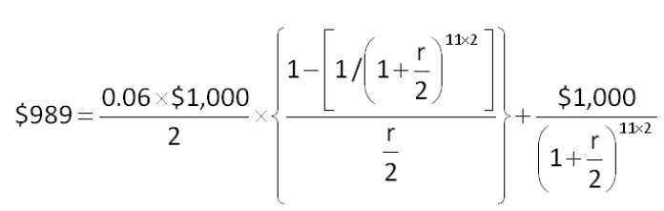
This cannot be solved directly, so it's easiest to just use the calculator method to get an answer. You can then use the calculator answer as the rate in the formula just to verify that your answer is correct.
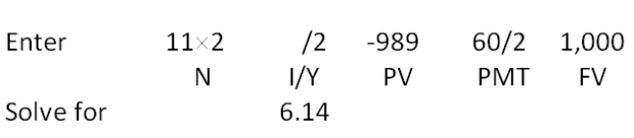

AACSB: Analytic
Bloom's: Application
Difficulty: Basic
Learning Objective: 7-2
Section: 7.1
Topic: Yield to maturity
81. Greenbrier Industrial Products' bonds have a 7.60 percent coupon and pay interest annually. The face value is $1,000 and the current market price is $1,062.50 per bond. The bonds mature in 16 years. What is the yield to maturity?
A. 6.94 percent
B. 7.22 percent
C. 7.46 percent
D. 7.71 percent
E. 7.80 percent
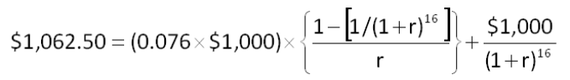
This cannot be solved directly, so it's easiest to just use the calculator method to get an answer. You can then use the calculator answer as the rate in the formula just to verify that your answer is correct.
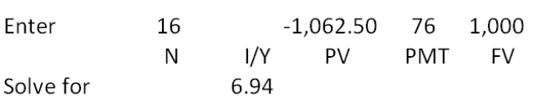

AACSB: Analytic
Bloom's: Application
Difficulty: Basic
Learning Objective: 7-2
Section: 7.1
Topic: Yield to maturity
82. Collingwood Homes has a bond issue outstanding that pays an 8.5 percent coupon and matures in 18.5 years. The bonds have a par value of $1,000 and a market price of $964.20. Interest is paid semiannually. What is the yield to maturity?
A. 8.36 percent
B. 8.42 percent
C. 8.61 percent
D. 8.74 percent
E. 8.90 percent
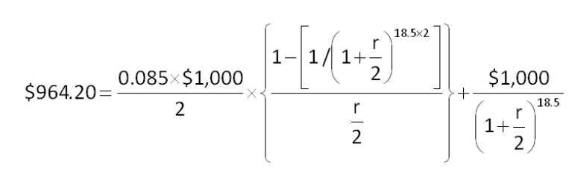
This cannot be solved directly, so it's easiest to just use the calculator method to get an answer. You can then use the calculator answer as the rate in the formula just to verify that your answer is correct.
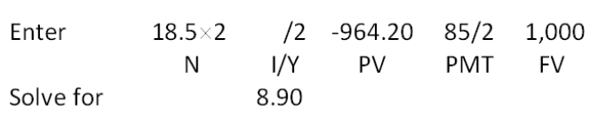

AACSB: Analytic
Bloom's: Application
Difficulty: Basic
Learning Objective: 7-2
Section: 7.1
Topic: Yield to maturity
83. Oil Well Supply offers 7.5 percent coupon bonds with semiannual payments and a yield to maturity of 7.68 percent. The bonds mature in 6 years. What is the market price per bond if the face value is $1,000?
A. $989.70
B. $991.47
C. $996.48
D. $1,002.60
E. $1,013.48
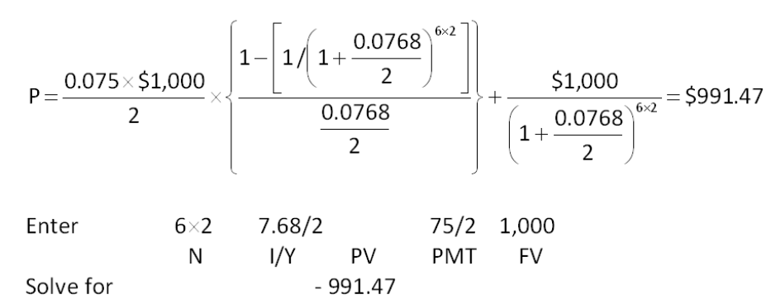

AACSB: Analytic
Bloom's: Application
Difficulty: Basic
Learning Objective: 7-2
Section: 7.1
Topic: Bond price
84. Roadside Markets has a 6.75 percent coupon bond outstanding that matures in 10.5 years. The bond pays interest semiannually. What is the market price per bond if the face value is $1,000 and the yield to maturity is 6.69 percent?
A. $999.80
B. $999.85
C. $1,003.42
D. $1,004.47
E. $1,007.52
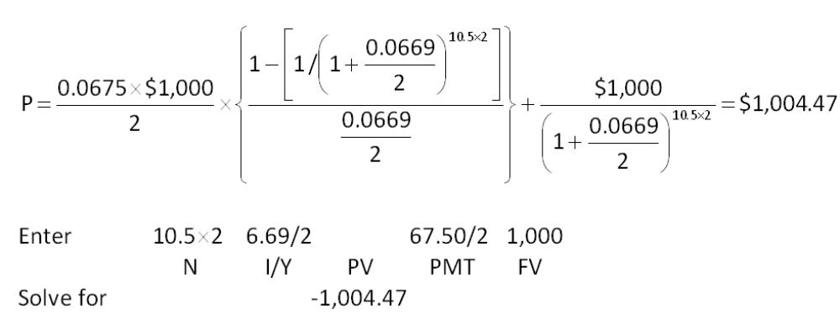

AACSB: Analytic
Bloom's: Application
Difficulty: Basic
Learning Objective: 7-2
Section: 7.1
Topic: Bond price
85. Grand Adventure Properties offers a 9.5 percent coupon bond with annual payments. The yield to maturity is 11.2 percent and the maturity date is 11 years from today. What is the market price of this bond if the face value is $1,000?
A. $895.43
B. $896.67
C. $941.20
D. $946.18
E. $953.30
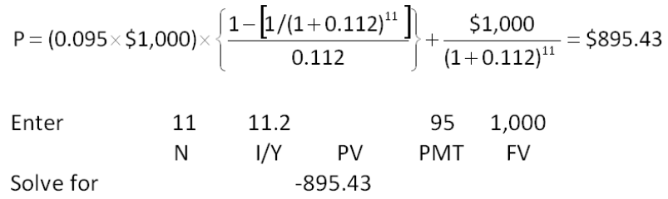

AACSB: Analytic
Bloom's: Application
Difficulty: Basic
Learning Objective: 7-2
Section: 7.1
Topic: Bond price
86. Redesigned Computers has 5.25 percent coupon bonds outstanding with a current market price of $546.19. The yield to maturity is 16.28 percent and the face value is $1,000. Interest is paid semiannually. How many years is it until these bonds mature?
A. 6.64 years
B. 7.08 years
C. 12.41 years
D. 14.16 years
E. 28.32 years
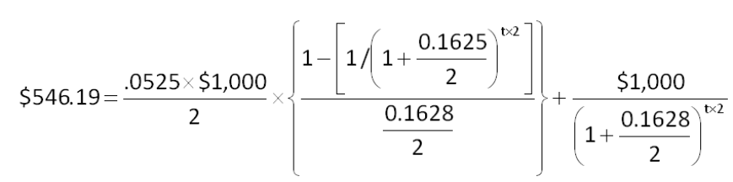
It's easiest to solve this problem using a financial calculator. You can then use the calculator answer as the time period in the formula just to verify that your answer is correct.
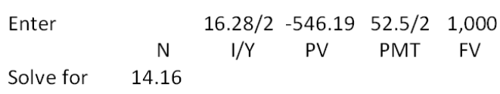
The number of six-month periods is 14.16. The number of years is 7.08 years.

AACSB: Analytic
Bloom's: Application
Difficulty: Basic
Learning Objective: 7-2
Section: 7.1
Topic: Time to maturity
87. Global Communications has a 7 percent, semiannual coupon bond outstanding with a current market price of $1,023.46. The bond has a par value of $1,000 and a yield to maturity of 6.72 percent. How many years is it until this bond matures?
A. 12.26 years
B. 12.53 years
C. 18.49 years
D. 24.37 years
E. 25.05 years
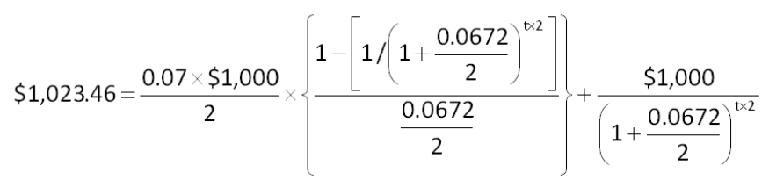
It's easiest to solve this problem using financial calculator. You can then use the calculator answer as the time period in the formula just to verify that your answer is correct.
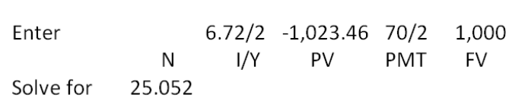
The number of six-month periods is 25.052. The number of years is 12.53 years.

AACSB: Analytic
Bloom's: Analysis
Difficulty: Basic
Learning Objective: 7-2
Section: 7.1
Topic: Time to maturity
88. You are purchasing a 25-year, zero-coupon bond. The yield to maturity is 8.68 percent and the face value is $1,000. What is the current market price?
A. $106.67
B. $108.18
C. $119.52
D. $121.50
E. $128.47
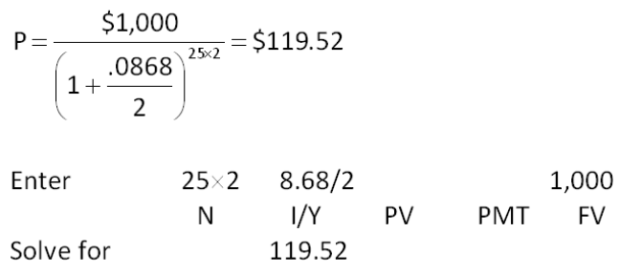

AACSB: Analytic
Bloom's: Application
Difficulty: Basic
Learning Objective: 7-2
Section: 7.1 and 7.4
Topic: Zero bond price
89. Today, you want to sell a $1,000 face value zero coupon bond you currently own. The bond matures in 4.5 years. How much will you receive for your bond if the market yield to maturity is currently 5.33 percent? Ignore any accrued interest.
A. $696.60
B. $698.09
C. $741.08
D. $756.14
E. $789.22
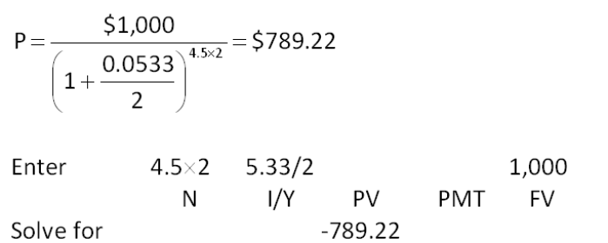

AACSB: Analytic
Bloom's: Application
Difficulty: Basic
Learning Objective: 7-2
Section: 7.1 and 7.4
Topic: Zero bond price
90. The zero coupon bonds of D&L Movers have a market price of $319.24, a face value of $1,000, and a yield to maturity of 9.17 percent. How many years is it until these bonds mature?
A. 11.92 years
B. 12.28 years
C. 12.73 years
D. 13.01 years
E. 13.47 years
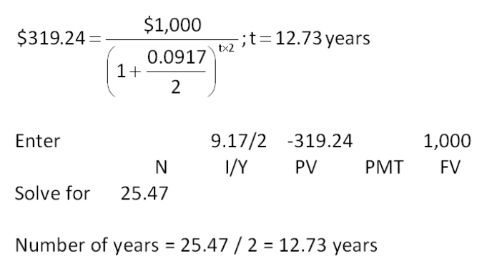

AACSB: Analytic
Bloom's: Application
Difficulty: Intermediate
Learning Objective: 7-1
Section: 7.1 and 7.4
Topic: Time to maturity
91. A 16-year, 4.5 percent coupon bond pays interest annually. The bond has a face value of $1,000. What is the percentage change in the price of this bond if the market yield to maturity rises to 5.7 percent from the current rate of 5.5 percent?
A. 2.14 percent decrease
B. 1.97 percent decrease
C. 0.21 percent increase
D. 1.97 percent increase
E. 2.14 percent increase
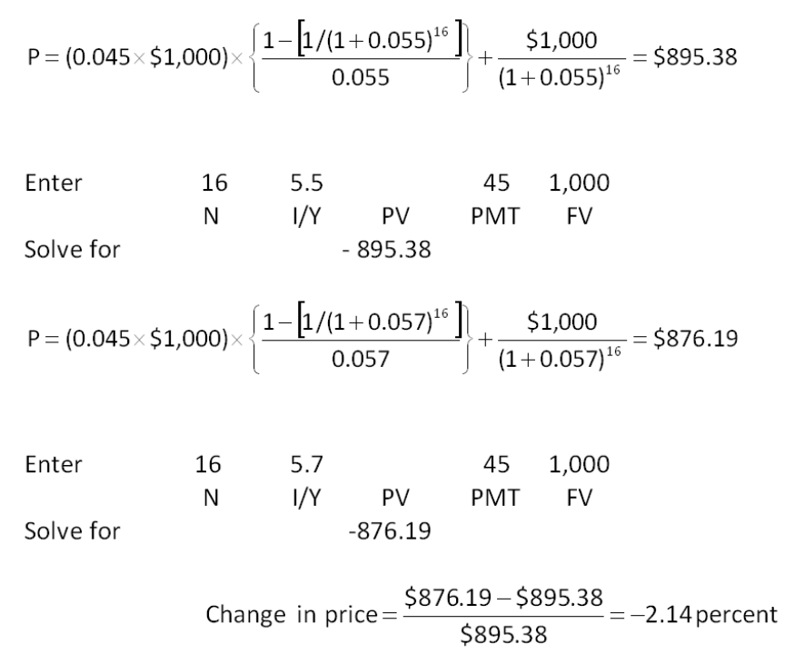

AACSB: Analytic
Bloom's: Analysis
Difficulty: Intermediate
Learning Objective: 7-1
Section: 7.1
Topic: Interest rate risk
92. The Corner Grocer has a 7-year, 6 percent annual coupon bond outstanding with a $1,000 par value. The bond has a yield to maturity of 5.5 percent. Which one of the following statements is correct if the market yield suddenly increases to 6.5 percent?
A. The bond price will increase by $57.14.
B. The bond price will increase by 5.29 percent.
C. The bond price will decrease by $53.62.
D. The bond price will decrease by 5.43 percent.
E. The bond price will decrease by 5.36 percent.
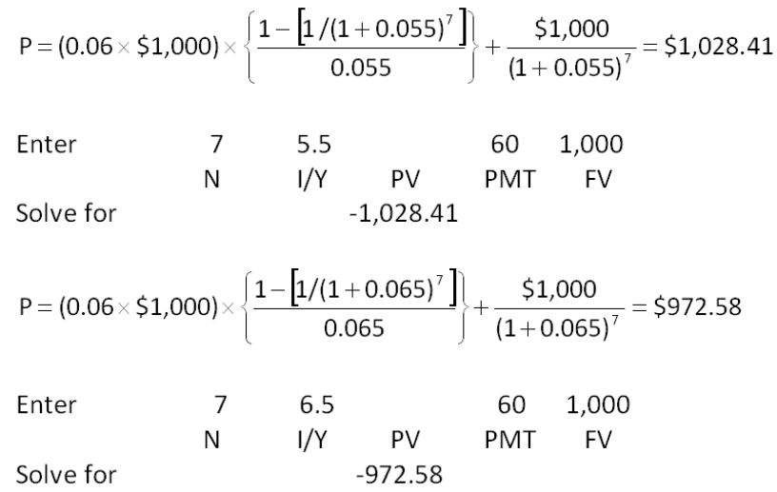
Difference in prices = $972.58 - $1,028.41 = -$55.83
Percentage difference in prices = 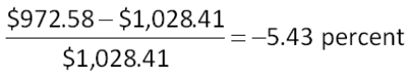

AACSB: Analytic
Bloom's: Analysis
Difficulty: Intermediate
Learning Objective: 7-2
Section: 7.1
Topic: Interest rate risk
93. Blackwell bonds have a face value of $1,000 and are currently quoted at 98.4. The bonds have a 5 percent coupon rate. What is the current yield on these bonds?
A. 4.67 percent
B. 4.78 percent
C. 5.08 percent
D. 5.33 percent
E. 5.54 percent
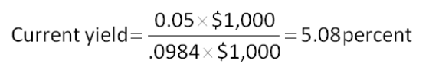

AACSB: Analytic
Bloom's: Application
Difficulty: Basic
Learning Objective: 7-2
Section: 7.1
Topic: Current yield
94. The outstanding bonds of The River Front Ferry carry a 6.5 percent coupon. The bonds have a face value of $1,000 and are currently quoted at 101.6. What is the current yield on these bonds?
A. 1.60 percent
B. 2.37 percent
C. 6.40 percent
D. 6.49 percent
E. 6.88 percent
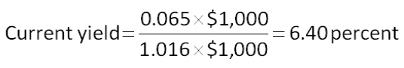

AACSB: Analytic
Bloom's: Application
Difficulty: Basic
Learning Objective: 7-2
Section: 7.1
Topic: Current yield
95. The 7 percent, semi-annual coupon bonds offered by House Renovators are callable in 2 years at $1,054. What is the amount of the call premium on a $1,000 par value bond?
A. $52
B. $54
C. $72
D. $84
E. $89
Call premium = $1,054 - $1,000 = $54

AACSB: Analytic
Bloom's: Application
Difficulty: Basic
Learning Objective: 7-2
Section: 7.2
Topic: Call premium
96. A corporate bond was quoted yesterday at 102.16 while today's quote is 102.19. What is the change in the value of a bond that has a face value of $6,000?
A. $0.30
B. $1.80
C. $3.00
D. $18.00
E. $180.00
Market price = (1.0219 - 1.0216) × $6,000 = $1.80

AACSB: Analytic
Bloom's: Application
Difficulty: Basic
Learning Objective: 7-2
Section: 7.5
Topic: Bond quote
97. A 10-year, 4.5 percent, semiannual coupon bond issued by Tyler Rentals has a $1,000 face value. The bond is currently quoted at 98.7. What is the clean price of this bond if the next interest payment will occur 2 months from today?
A. $987.00
B. $994.50
C. $1,002.00
D. $1,011.25
E. $1,022.50
Clean price = 0.987 × $1,000 = $987

AACSB: Analytic
Bloom's: Application
Difficulty: Basic
Learning Objective: 7-2
Section: 7.5
Topic: Clean price
98. A Treasury bond is quoted at a price of 105:15. What is the market price of this bond if the face value is $5,000?
A. $5,005.15
B. $5,105.15
C. $5,257.50
D. $5,273.44
E. $5,515.00
Price = 105:15 = 105 and 15/32 percent of face = 1.0546875 × $5,000 = $5,273.44

AACSB: Analytic
Bloom's: Application
Difficulty: Basic
Learning Objective: 7-2
Section: 7.5
Topic: Treasury bond quote
99. A Treasury bond is quoted at a price of 101:14 with a current yield of 7.236 percent. What is the coupon rate?
A. 7.20 percent
B. 7.28 percent
C. 7.30 percent
D. 7.34 percent
E. 7.39 percent
Price = 101 and 14/32 percent of face = 1.014375 × $1,000 = $1,014.375
Annual interest = 0.07236 × $1,014.375 = $73.40
Coupon rate = $73.40/$1,000 = 7.34 percent

AACSB: Analytic
Bloom's: Application
Difficulty: Intermediate
Learning Objective: 7-2
Section: 7.1
Topic: Bond yields
100. A corporate bond is quoted at a price of 103.16 and carries a 6.50 percent coupon. The bond pays interest semiannually. What is the current yield on one of these bonds?
A. 6.24 percent
B. 6.30 percent
C. 6.36 percent
D. 6.62 percent
E. 6.66 percent
Current yield = (0.065 × $1,000)/(1.0316 × $1,000) = 6.30 percent

AACSB: Analytic
Bloom's: Application
Difficulty: Basic
Learning Objective: 7-1
Section: 7.1
Topic: Current yield
101. A Treasury bond is quoted at a price of 106:23 with a 3.50 percent coupon. The bond pays interest semiannually. What is the current yield on one of these bonds?
A. 3.06 percent
B. 3.19 percent
C. 3.28 percent
D. 3.33 percent
E. 3.38 percent
Current price = 106 and 23/32nds percent of face = 1.0671875 × $1,000 = $1,067.1875
Current yield = (0.035 × $1,000)/$1,067.1875 = 3.28 percent

AACSB: Analytic
Bloom's: Application
Difficulty: Basic
Learning Objective: 7-2
Section: 7.1 and 7.5
Topic: Treasury yield
102. A Treasury bond is quoted as 99:11 asked and 99:09 bid. What is the bid-ask spread in dollars on a $5,000 face value bond?
A. $0.03
B. $0.63
C. $1.00
D. $3.13
E. $6.25
Bid-ask spread = 99:11 - 99:09 = 2/32 of 1 percent of $5,000 = $3.13

AACSB: Analytic
Bloom's: Application
Difficulty: Basic
Learning Objective: 7-2
Section: 7.5
Topic: Bid-ask spread
103. The semiannual, 8-year bonds of Alto Music are selling at par and have an effective annual yield of 8.6285 percent. What is the amount of each interest payment if the face value of the bonds is $1,000?
A. $41.50
B. $42.25
C. $43.15
D. $85.00
E. $86.29
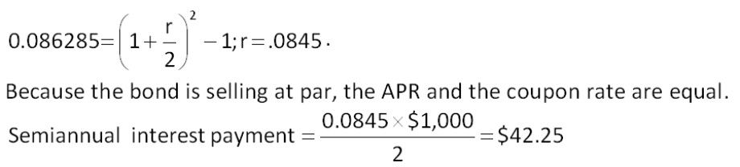

AACSB: Analytic
Bloom's: Analysis
Difficulty: Intermediate
Learning Objective: 7-1
Section: 7.1
Topic: Bond yields and payments
104. A bond that pays interest annually yielded 7.47 percent last year. The inflation rate for the same period was 6.10 percent. What was the actual real rate of return on this bond for last year?
A. 1.19 percent
B. 1.25 percent
C. 1.29 percent
D. 1.36 percent
E. 1.41 percent
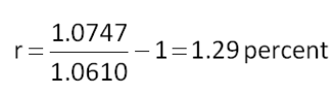

AACSB: Analytic
Bloom's: Application
Difficulty: Basic
Learning Objective: 7-4
Section: 7.6
Topic: Real return
105. Getty Markets has bonds outstanding that pay a 5 percent semiannual coupon, have a 5.28 percent yield to maturity, and a face value of $1,000. The current rate of inflation is 4.1 percent. What is the real rate of return on these bonds?
A. 0.86 percent
B. 0.90 percent
C. 1.04 percent
D. 1.13 percent
E. 1.19 percent
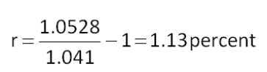

AACSB: Analytic
Bloom's: Application
Difficulty: Basic
Learning Objective: 7-4
Section: 7.6
Topic: Real rate
106. The outstanding bonds of Winter Time Products provide a real rate of return of 3.03 percent. The current rate of inflation is 4.68 percent. What is the actual nominal rate of return on these bonds?
A. 7.58 percent
B. 7.33 percent
C. 7.71 percent
D. 7.76 percent
E. 7.85 percent
(1 + 0.0303) × (1 + 0.0468) - 1 = 7.85 percent

AACSB: Analytic
Bloom's: Application
Difficulty: Basic
Learning Objective: 7-4
Section: 7.6
Topic: Fisher effect
107. The yield to maturity on a bond is currently 8.46 percent. The real rate of return is 3.22 percent. What is the rate of inflation?
A. 5.08 percent
B. 5.64 percent
C. 6.24 percent
D. 6.53 percent
E. 6.71 percent
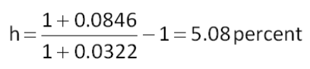

AACSB: Analytic
Bloom's: Application
Difficulty: Basic
Learning Objective: 7-4
Section: 7.6
Topic: Fisher effect
108. A zero coupon bond with a face value of $1,000 is issued with an initial price of $212.56. The bond matures in 25 years. What is the implicit interest, in dollars, for the first year of the bond's life?
A. $12.72
B. $13.58
C. $13.90
D. $15.63
E. $15.89
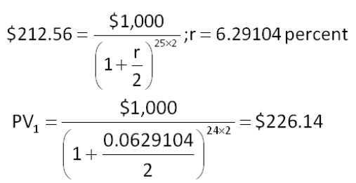
Implicit interest = $226.14 - $212.56 = $13.58

AACSB: Analytic
Bloom's: Application
Difficulty: Intermediate
Learning Objective: 7-1
Section: 7.4
Topic: Implicit interest
109. Northern Warehouses wants to raise $11.4 million to expand its business. To accomplish this, it plans to sell 40-year, $1,000 face value, zero-coupon bonds. The bonds will be priced to yield 8.75 percent. What is the minimum number of bonds it must sell to raise the $11.4 million it needs?
A. 210,411
B. 239,800
C. 254,907
D. 326,029
E. 350,448
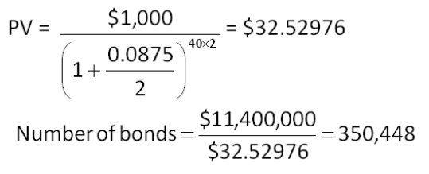

AACSB: Analytic
Bloom's: Application
Difficulty: Basic
Learning Objective: 7-2
Section: 7.4
Topic: Zero-coupon bond
110. You have won a contest and will receive $2,500 a year in real terms for the next 3 years. Each payment will be received at the end of the period with the first payment occurring one year from today. The relevant nominal discount rate is 6.3 percent and the inflation rate is 4.5 percent. What are your winnings worth today?
A. $7,249
B. $7,367
C. $7,401
D. $7,500
E. $7,838
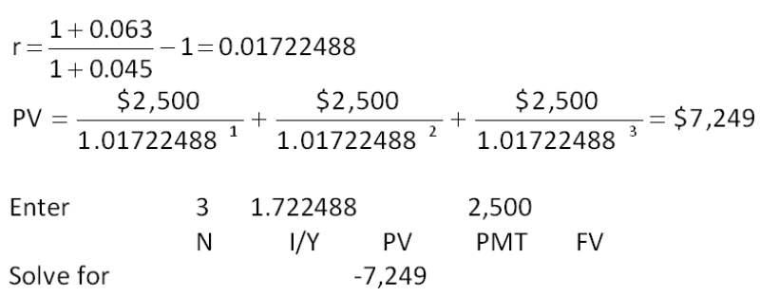

AACSB: Analytic
Bloom's: Application
Difficulty: Intermediate
Learning Objective: 7-4
Section: 7.6
Topic: Real cash flows
111. You purchased an investment which will pay you $8,000, in real dollars, a year for the next three years. Each payment will be received at the end of the period with the first payment occurring one year from today. The nominal discount rate is 7.5 percent and the inflation rate is 2.9 percent. What is the present value of these payments?
A. $21,720
B. $22,004
C. $22,511
D. $23,406
E. $23,529
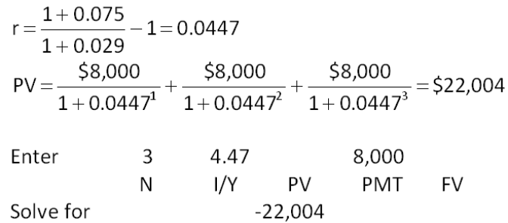

AACSB: Analytic
Bloom's: Application
Difficulty: Intermediate
Learning Objective: 7-4
Section: 7.6
Topic: Real cash flows

Essay Questions
112. Define liquidity risk, default risk, and taxability risk and explain how these risks relate to bonds and bond yields.
Liquidity risk is the inability to quickly sell a bond for its full value. This risk exists primarily in thinly traded issues. Default risk is the likelihood the issuer will default on its bond obligations and is the basis for bond ratings. Taxability risk reflects the fact that bond interest can be taxed differently at the federal, state, and local levels and that these tax rates can change. Each of these risks increase bond yields as investors require compensation in exchange for risk acceptance.
Feedback: Refer to section 7.7

AACSB: Reflective thinking
Bloom's: Analysis
Difficulty: Intermediate
Learning Objective: 7-5
Section: 7.7
Topic: Determinants of bond yields
113. Inflation has remained low for the past three years but you have come to the conclusion that trend is ending and inflation will increase significantly over the next 18 months. Assume you have reached this conclusion prior to other investors reaching the same conclusion. What adjustments should you make to your bond portfolio in light of your conclusions?
Increases in inflation will increase interest rates according to the term structure of interest rates. Therefore, you should sell any long-term bonds you own and replace them with short-term bonds. You should also replace lower coupon bonds with higher coupon bonds. These changes should be done promptly before other investors commence taking the same actions.
Feedback: Refer to section 7.7

AACSB: Reflective thinking
Bloom's: Analysis
Difficulty: Intermediate
Learning Objective: 7-5
Section: 7.7
Topic: Term structure and interest rate risk
114. Explain the conditions that would need to exist for the Treasury yield curve to be downward sloping.
A downward sloping Treasury yield curve exists when current inflation rates are high but are expected to decline in the future. The decline in the inflation premium must be significant enough to overcome the rising interest rate risk premium as the time to maturity increases.
Feedback: Refer to section 7.7

AACSB: Reflective thinking
Bloom's: Analysis
Difficulty: Intermediate
Learning Objective: 7-5
Section: 7.7
Topic: Treasury yield curve
115. Describe the relationships that exist between the coupon rate, the yield to maturity, and the current yield for both a discount bond and a premium bond.
Discount bond: Yield to maturity > Current yield > Coupon rate
Premium bond: Yield to maturity < Current yield < Coupon rate
Feedback: Refer to section 7.1

AACSB: Reflective thinking
Bloom's: Analysis
Difficulty: Intermediate
Learning Objective: 7-2
Section: 7.1
Topic: Bond yields

Multiple Choice Questions
116. Sylvan Trees has a 7 percent coupon bond on the market with ten years left to maturity. The bond makes annual payments and currently sells for $861.20. What is the yield-to-maturity?
A. 8.50 percent
B. 8.68 percent
C. 8.92 percent
D. 9.18 percent
E. 9.27 percent
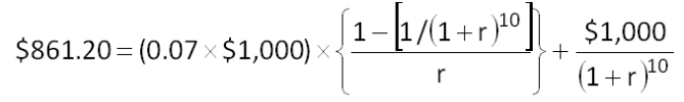
This cannot be solved directly, so it's easiest to just use the calculator method to get an answer. You can then use the calculator answer as the rate in the formula just to verify that your answer is correct.
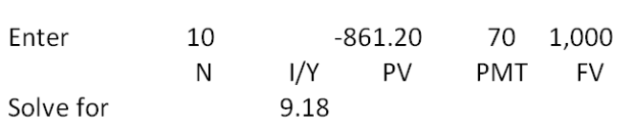

AACSB: Analytic
Bloom's: Application
Difficulty: Basic
EOC #: 7-4
Learning Objective: 7-2
Section: 7.1
Topic: Yield to maturity
117. Kaiser Industries has bonds on the market making annual payments, with 14 years to maturity, and selling for $1,382.01. At this price, the bonds yield 7.5 percent. What is the coupon rate?
A. 8.00 percent
B. 8.50 percent
C. 9.00 percent
D. 10.50 percent
E. 12.00 percent
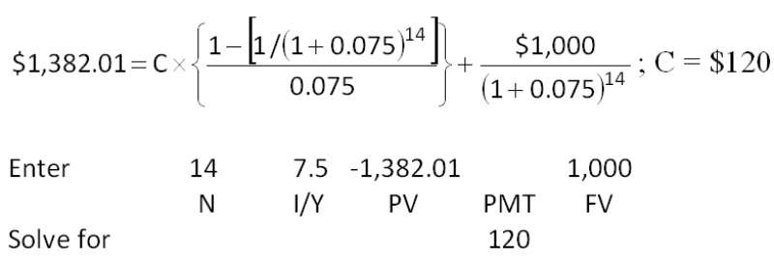
Coupon rate = $120/$1,000 = 12 percent

AACSB: Analytic
Bloom's: Application
Difficulty: Basic
EOC #: 7-5
Learning Objective: 7-2
Section: 7.1
Topic: Coupon rate
118. Dexter Mills issued 20-year bonds a year ago at a coupon rate of 11.4 percent. The bonds make semiannual payments. The yield-to-maturity on these bonds is 9.2 percent. What is the current bond price?
A. $985.55
B. $991.90
C. $1,192.16
D. $1,195.84
E. $1,198.00
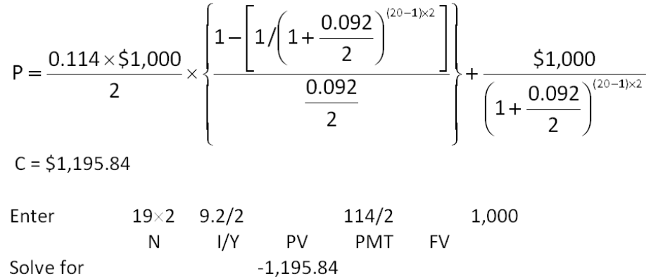

AACSB: Analytic
Bloom's: Application
Difficulty: Basic
EOC #: 7-6
Learning Objective: 7-2
Section: 7.1
Topic: Bond price
119. Soo Lee Imports issued 17-year bonds 2 years ago at a coupon rate of 10.3 percent. The bonds make semiannual payments. These bonds currently sell for 102 percent of par value. What is the yield-to-maturity?
A. 9.98 percent
B. 10.04 percent
C. 10.13 percent
D. 10.27 percent
E. 10.42 percent
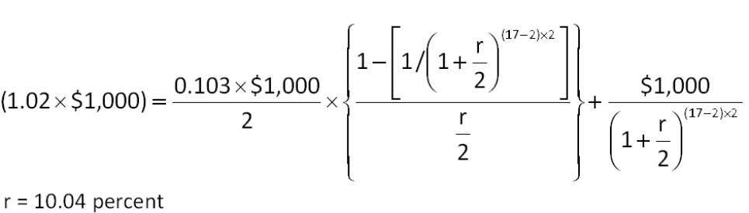
This cannot be solved directly, so it's easiest to just use the calculator method to get an answer. You can then use the calculator answer as the rate in the formula just to verify that your answer is correct.
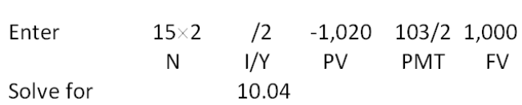

AACSB: Analytic
Bloom's: Application
Difficulty: Basic
EOC #: 7-7
Learning Objective: 7-2
Section: 7.1
Topic: Yield to maturity
120. Bryceton, Inc. has bonds on the market with 13 years to maturity, a yield-to-maturity of 9.2 percent, and a current price of $895.09. The bonds make semiannual payments. What is the coupon rate?
A. 7.80 percent
B. 8.00 percent
C. 8.25 percent
D. 8.40 percent
E. 8.65 percent
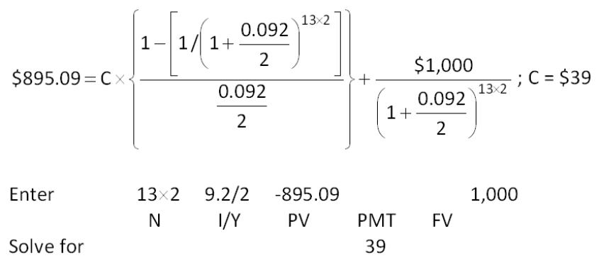
Coupon rate = ($39 × 2)/$1,000 = 7.80 percent

AACSB: Analytic
Bloom's: Application
Difficulty: Basic
EOC #: 7-8
Learning Objective: 7-2
Section: 7.1
Topic: Coupon rate
121. Suppose the real rate is 9.5 percent and the inflation rate is 1.8 percent. What rate would you expect to see on a Treasury bill?
A. 9.50 percent
B. 11.30 percent
C. 11.47 percent
D. 11.56 percent
E. 11.60 percent
(1 + R) = (1 + 0.095) × (1 + 0.018); R = 11.47 percent

AACSB: Analytic
Bloom's: Application
Difficulty: Basic
EOC #: 7-10
Learning Objective: 7-4
Section: 7.6
Topic: Nominal rate
122. An investment offers a 10.5 percent total return over the coming year. Sam Bernanke thinks the total real return on this investment will be only 4.5 percent. What does Sam believe the inflation rate will be for the next year?
A. 5.60 percent
B. 5.67 percent
C. 5.74 percent
D. 6.00 percent
E. 6.21 percent
(1 + 0.105) = (1 + 0.045) × (1 + h); h = 5.74 percent

AACSB: Analytic
Bloom's: Application
Difficulty: Basic
EOC #: 7-11
Learning Objective: 7-4
Section: 7.6
Topic: Inflation rate
123. Bond S is a 4 percent coupon bond. Bond T is a 10 percent coupon bond. Both bonds have 11 years to maturity, make semiannual payments, and have a yield-to-maturity of 7 percent. If interest rates suddenly rise by 2 percent, what will the percentage change in the price of Bond T be?
A. -15.16 percent
B. -14.87 percent
C. -13.56 percent
D. -12.92 percent
E. -12.67 percent
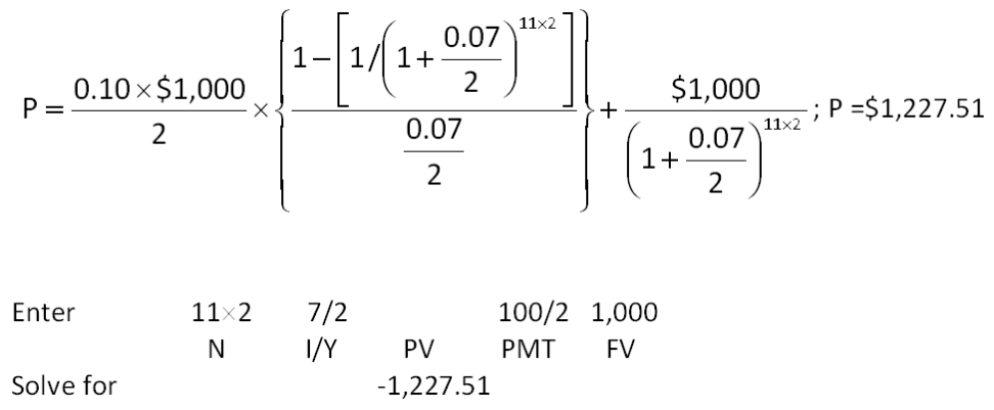
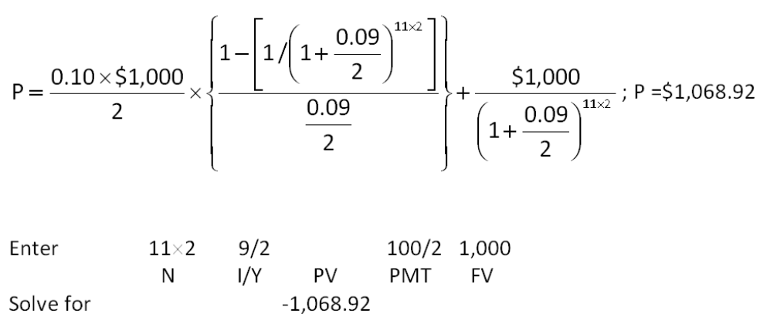
Percentage change in price = ($1,068.92 - $1,227.51)/$1,227.51 = -12.92 percent

AACSB: Analytic
Bloom's: Application
Difficulty: Intermediate
EOC #: 7-17
Learning Objective: 7-1
Section: 7.1
Topic: Interest rate risk
124. Technical Sales, Inc. has 6.6 percent coupon bonds on the market with 9 years left to maturity. The bonds make semiannual payments and currently sell for 88.79 percent of par. What is the effective annual yield?
A. 8.34 percent
B. 8.40 percent
C. 8.52 percent
D. 8.58 percent
E. 8.60 percent
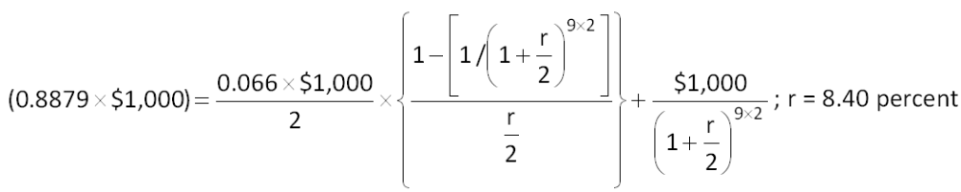
This cannot be solved directly, so it's easiest to just use the calculator method to get an answer. You can then use the calculator answer as the rate in the formula just to verify that your answer is correct.
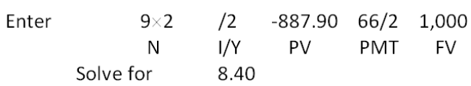
Effective annual rate = [1 + (0.0840/2)]² - 1 = 8.58 percent

AACSB: Analytic
Bloom's: Analysis
Difficulty: Intermediate
EOC #: 7-18
Learning Objective: 7-2
Section: 7.1
Topic: Effective bond yield
125. Bonner Metals wants to issue new 18-year bonds for some much-needed expansion projects. The company currently has 11 percent bonds on the market that sell for $1,459.51, make semiannual payments, and mature in 18 years. What should the coupon rate be on the new bonds if the firm wants to sell them at par?
A. 5.75 percent
B. 6.23 percent
C. 6.41 percent
D. 6.60 percent
E. 6.79 percent
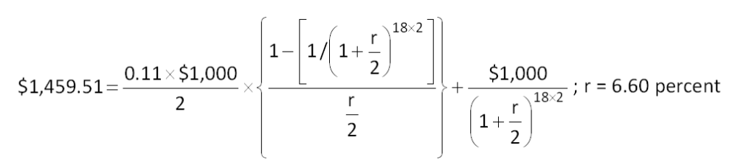
This cannot be solved directly, so it's easiest to just use the calculator method to get an answer. You can then use the calculator answer as the rate in the formula just to verify that your answer is correct.
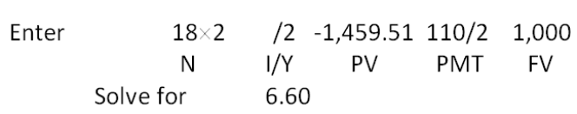
To sell a bond at par, the coupon rate must be set equal to the required return.

AACSB: Analytic
Bloom's: Analysis
Difficulty: Intermediate
EOC #: 7-19
Learning Objective: 7-1
Section: 7.1
Topic: Bond yields
126. You purchase a bond with an invoice price of $1,460. The bond has a coupon rate of 9.4 percent, and there are 3 months to the next semiannual coupon date. What is the clean price of this bond?
A. $1,436.50
B. $1,452.17
C. $1,460.00
D. $1,467.83
E. $1,483.50
Accrued interest = (0.094 × $1,000) × (3/12) = $23.50
Clean price = $1,460 - $23.50 = $1,436.50

AACSB: Analytic
Bloom's: Application
Difficulty: Intermediate
EOC #: 7-20
Learning Objective: 7-1
Section: 7.5
Topic: Accrued interest
127. Suppose the following bond quote for the Beta Company appears in the financial page of today's newspaper. Assume the bond has a face value of $1,000 and the current date is April 15, 2009. What is the yield to maturity on this bond?
A. 6.64 percent
B. 8.96 percent
C. 10.23 percent
D. 12.47 percent
E. 13.27 percent
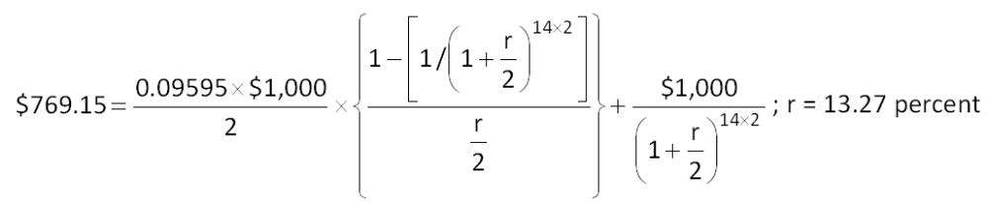
This cannot be solved directly, so it's easiest to just use the calculator method to get an answer. You can then use the calculator answer as the rate in the formula just to verify that your answer is correct.
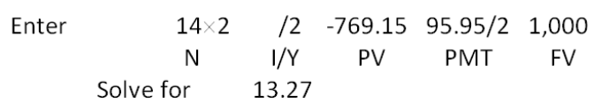

AACSB: Analytic
Bloom's: Analysis
Difficulty: Intermediate
EOC #: 7-23
Learning Objective: 7-5
Section: 7.7
Topic: Using bond quotes
128. You want to have $1.04 million in real dollars in an account when you retire in 46 years. The nominal return on your investment is 8 percent and the inflation rate is 3.5 percent. What is the real amount you must deposit each year to achieve your goal?
A. $6,667.67
B. $6,878.49
C. $7,433.02
D. $7,515.09
E. $7,744.12
(1 + 0.08) = (1 + r) × (1 + 0.035); r = 4.347826 percent
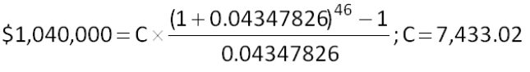

AACSB: Analytic
Bloom's: Analysis
Difficulty: Intermediate
EOC #: 7-28
Learning Objective: 7-4
Section: 7.6
Topic: Real cash flows
129. The yield-to-maturity on a bond is the interest rate you earn on your investment if interest rates do not change. If you actually sell the bond before it matures, your realized return is known as the holding period yield. Suppose that today, you buy a 12 percent annual coupon bond for $1,000. The bond has 13 years to maturity. Two years from now, the yield-to-maturity has declined to 11 percent and you decide to sell. What is your holding period yield?
A. 8.84 percent
B. 9.49 percent
C. 12.00 percent
D. 13.01 percent
E. 14.89 percent
The yield-to-maturity at the time of purchase must be 12 percent, which is the coupon rate, because the bond was purchased at par value.
Yield-to-maturity in 2 years = 12 percent - 1 percent = 11 percent
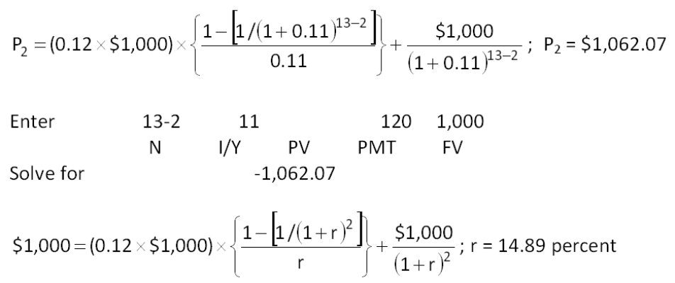
This cannot be solved directly, so it's easiest to just use the calculator method to get an answer. You can then use the calculator answer as the rate in the formula just to verify that your answer is correct.
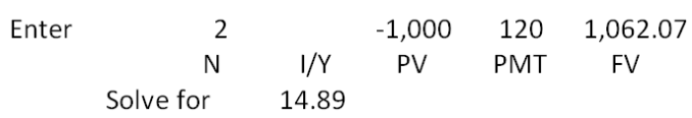

AACSB: Analytic
Bloom's: Analysis
Difficulty: Challenge
EOC #: 7-30
Learning Objective: 7-1
Section: 7.1
Topic: Holding period yield

